User Manual — Sistem Jejak GPL
This manual explains how to use Sistem Jejak GPL, the FAMA portal for tracing exported agricultural produce. Screens in this manual were taken from the live site:
https://jejakgpl.metadatasystem.my
The screens are in Malay. This manual uses those same labels, so you can follow them on the page.
Figures on the dashboards (how many QR codes, how many applications) change as people use the system. The pictures show the site as it stood when this manual was written.

What the system does
An usahawan records an export. Pegawai FAMA reviews it. After FAMA approves, the public can open a product page from the QR code on the label.
A QR can exist before approval. Until FAMA approves, the public page says QR Belum Diaktifkan and shows only the QR ID. Approval turns that same QR Aktif and opens the traceability page. Rejection leaves the QR inactive.
After a QR is active, the company holding the lot can split the remaining quantity into smaller lots. Each piece gets its own QR, linked back to the original batch. The public page shows those stops under Jejak pecahan.
DagangNet and iFAMA in this version are lookup lists inside the prototype. Certificate files are copies the company uploads. There is no live check with a certificate authority, and there is no connection to a label printer.

Who uses it
Person | What they do
Usahawan | Keeps the company profile, files an export application, downloads the QR, and splits a lot
Pegawai FAMA | Monitors the system, approves or rejects applications, and can register a vendor and issue an active QR directly
Public | Opens a QR link. No login. Sees the product page only when the QR is active

On the sign-in screen the role switch must match the account. USAHAWAN is for the company user. FAMA is for the officer.

Contents
- Open the system and sign in
- Register as an usahawan
- Register as Pegawai FAMA
- Usahawan — home
- Usahawan — company profile
- Usahawan — applications
- Usahawan — QR codes
- Usahawan — split a lot
- Usahawan — audit trail
- Pegawai FAMA — monitoring
- Pegawai FAMA — review and decision
- Pegawai FAMA — companies and direct QR
- Public traceability page
- Phone layout
- Statuses
- Demonstration accounts
- What this version does not do
- Messages you may see

1. Open the system and sign in
Open https://jejakgpl.metadatasystem.my. The home page sends you to Log Masuk.
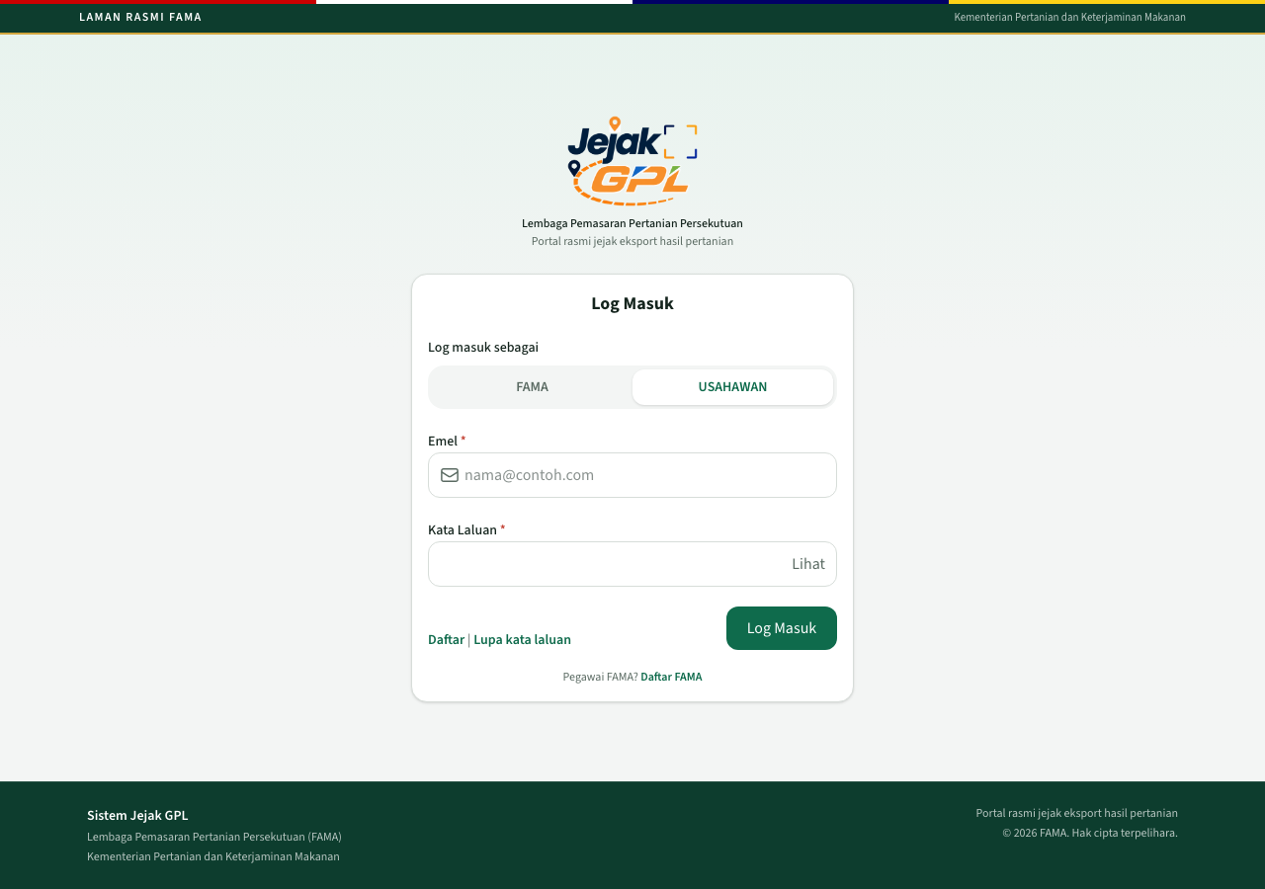
Log Masuk
- Under Log masuk sebagai, choose USAHAWAN or FAMA.
- Enter Emel and Kata Laluan.
- Lihat shows the password.
- Click Log Masuk.
An usahawan lands on Utama. An officer lands on Utama FAMA.
Daftar starts usahawan registration. Daftar FAMA starts officer registration. Lupa kata laluan explains that email reset is not connected yet. Use an existing account, or register again through the company or staff lookup.
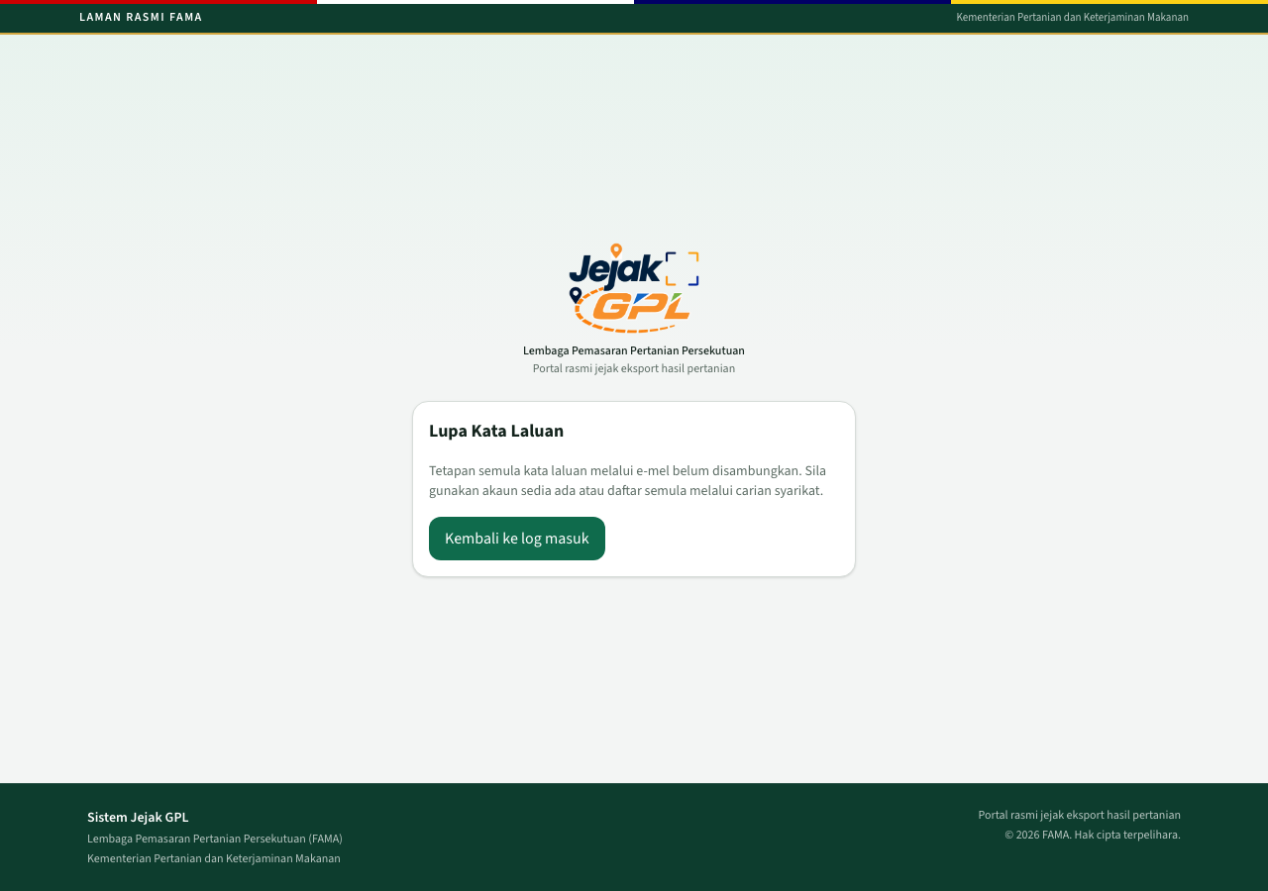
Lupa kata laluan
Log Keluar is at the bottom of the left menu.
The bell in the header shows how many notices are still unread. It is a count, and it does not open a separate inbox.
If one login is tied to more than one company, a Syarikat aktif list appears above the page. Choosing a company switches the records you are working on.

2. Register as an usahawan
From Log Masuk, click Daftar. Registration has four steps. The lookup uses the prototype company list.
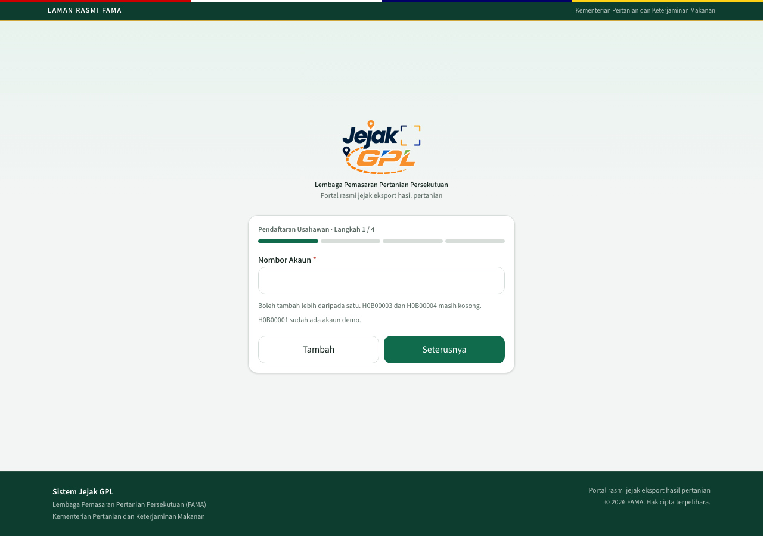
Daftar usahawan, step 1

Step 1 — Nombor Akaun
Type the DagangNet account number and click Seterusnya. Tambah puts the number on a list so one login can cover more than one company. Add every number first, then click Seterusnya.
A number that is not in the list shows Tiada rekod dijumpai.
On this site, H0B00001 already belongs to the ABC Fruits demonstration account. The screen says H0B00003 and H0B00004 are still free. Finish registration only when you mean to create a new login. Stopping after step 2 leaves the database unchanged.

Step 2 — Maklumat Syarikat
The lookup returns the company name, account number, email, and status. Check that this is the right company, then click Seterusnya.
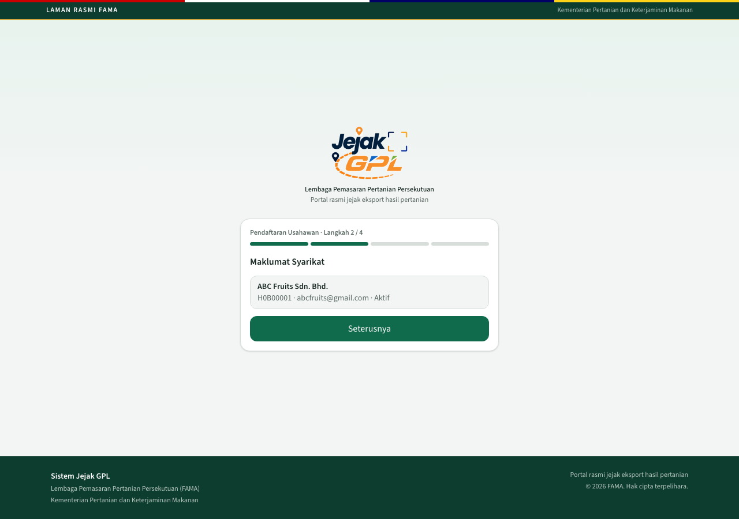
Company found for H0B00001

Step 3 — Maklumat Pengguna
Enter the user’s identity card number and name. The sample text already in the boxes is placeholder text. Replace it with the real user.
Peranan dalam rantaian is stored on the company and later appears on Jejak pecahan:
Choice | Meaning on the chain
Pembekal | Supplier
Pengeksport | Exporter
Pemasar | Marketer
Peruncit | Retailer
Lain-lain | A custom layer. Nama lapisan is required, for example Pengumpul

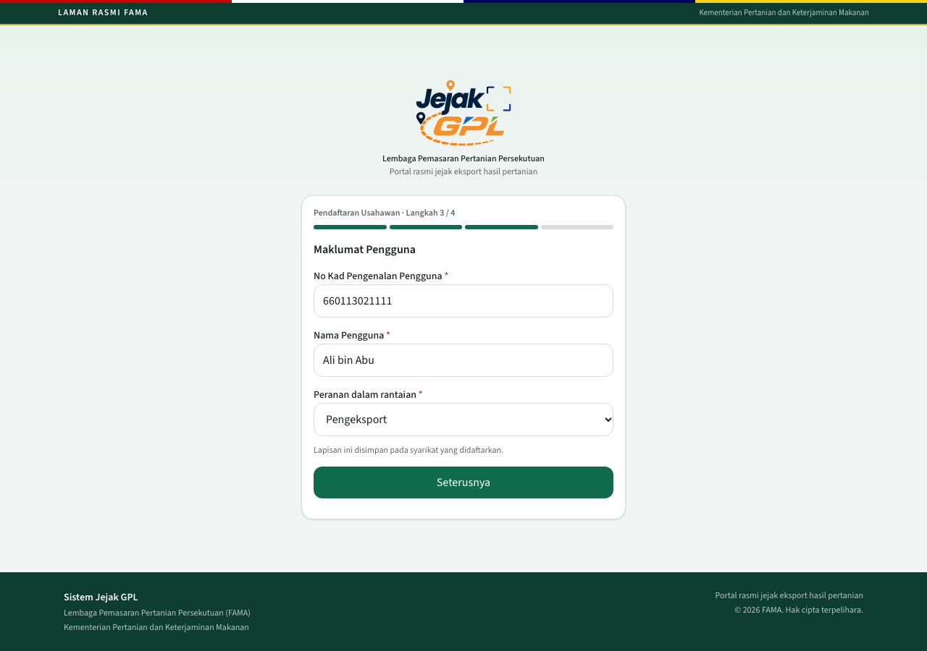
Usahawan details and chain role

Step 4 — Kata Laluan
The login email is the email of the first company you added. Set a password of at least 8 characters, confirm it, and click Daftar.
If the passwords do not match, or no company was added, the page asks you to check the password and the user details. For Lain-lain, an empty layer name shows Nama lapisan diperlukan untuk Lain-lain.

3. Register as Pegawai FAMA
From Log Masuk, click Daftar FAMA. Registration has three steps. The lookup uses the prototype iFAMA staff list.
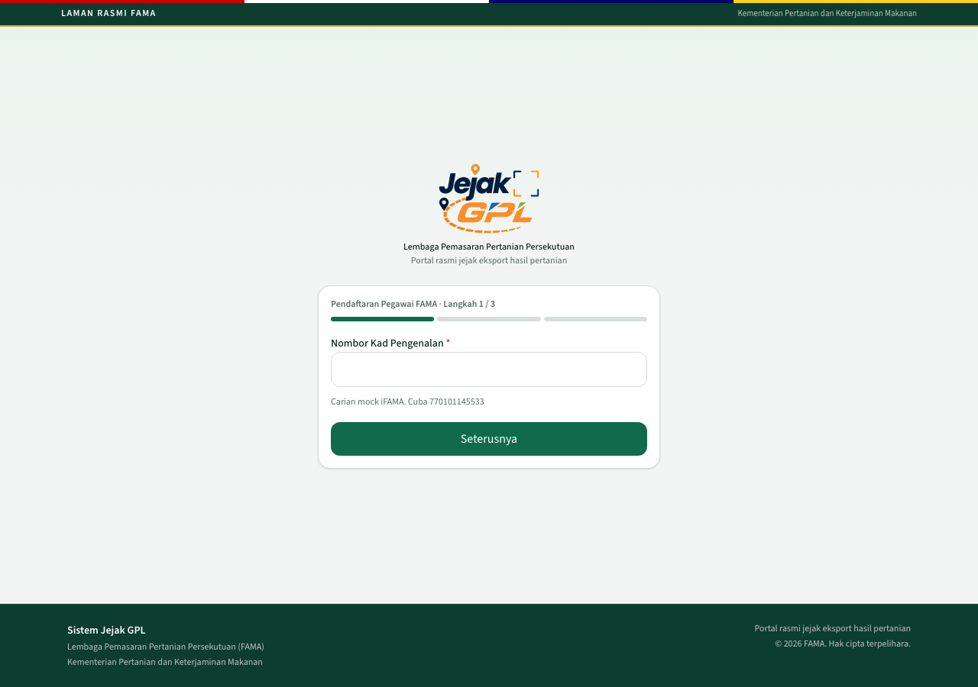
Daftar FAMA, step 1
- Enter Nombor Kad Pengenalan and click Seterusnya.
- Step 2 shows the officer’s name, email, and jawatan. These fields are read-only.
- Step 3 asks for a password and a confirmation, at least 8 characters. Click Daftar.
An identity number that is not in the list shows Tiada rekod dijumpai. A password problem shows Sila semak kata laluan.
The demonstration officer 770101145533 already has an account. The picture below is the confirmation step only. Stop there unless you are creating a new officer.
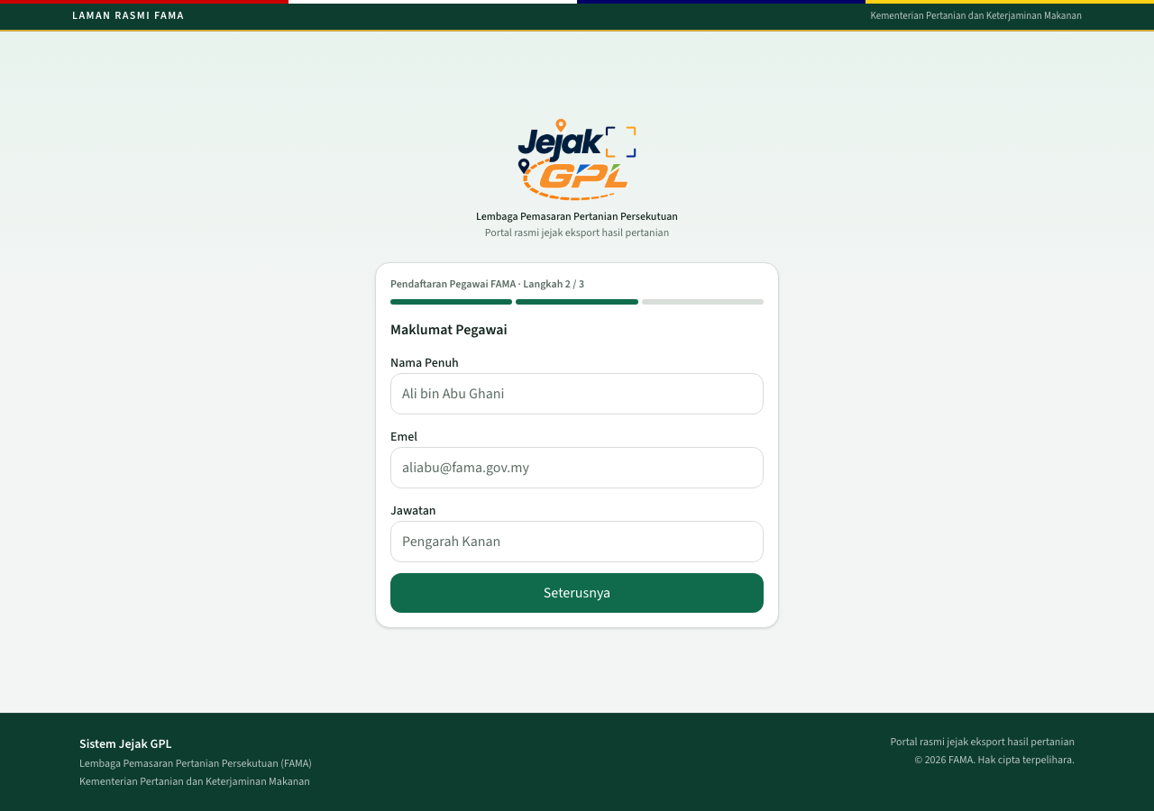
Officer found

4. Usahawan — home
After sign-in the usahawan sees Utama.
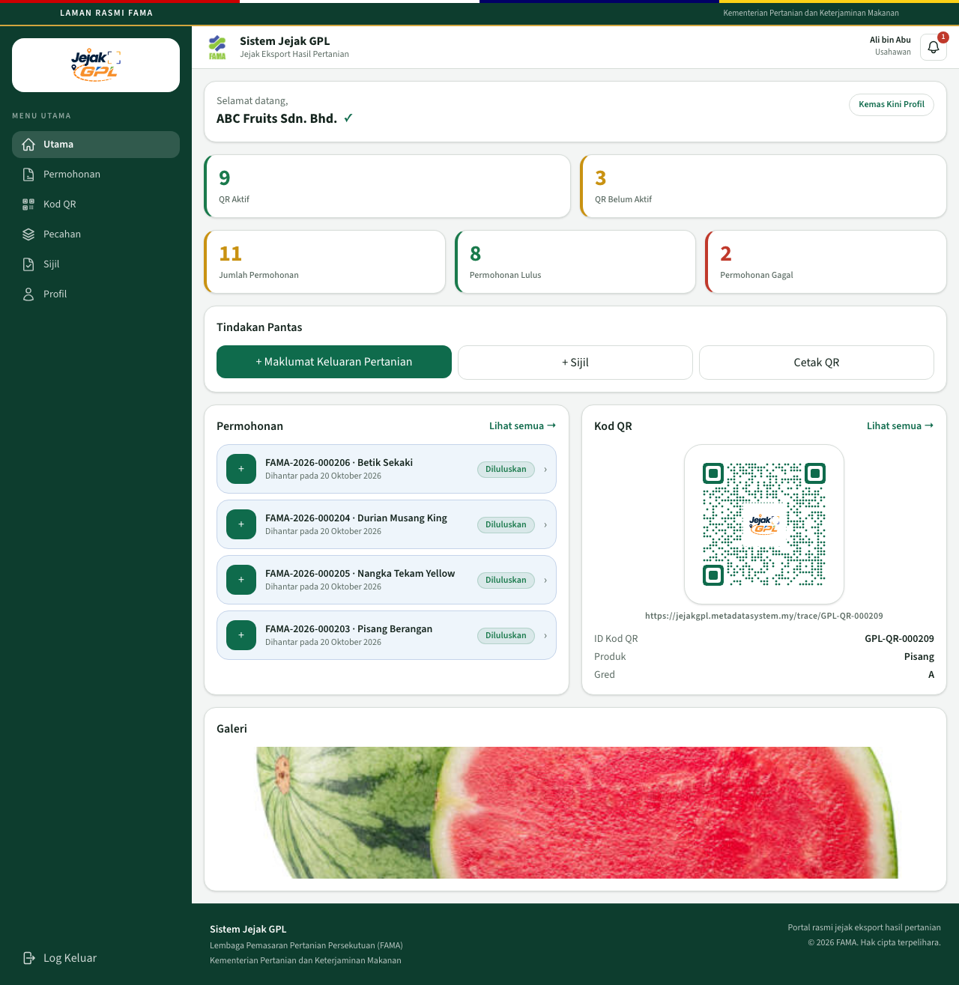
Usahawan home
The tick beside the company name means the account is tied to a company record.
Item | Meaning
QR Aktif | QR codes the public can open
QR Belum Aktif | QR codes that exist, still waiting for approval or rejected
Jumlah Permohonan | All applications for this company
Permohonan Lulus | Approved
Permohonan Gagal | Rejected
Tindakan Pantas | Shortcuts to produce, certificates, and QR printing
Permohonan | The latest applications. Lihat semua opens the full list
Kod QR | One QR from this company, with its public link
Galeri | The latest company photo

The left menu on a computer:
- Utama
- Permohonan
- Kod QR
- Pecahan
- Sijil
- Profil
Kemas Kini Profil opens the company profile.

5. Usahawan — company profile
Open Profil, or Kemas Kini Profil. Four tabs sit across the top: Syarikat, Keluaran, Sijil, Galeri.

Syarikat
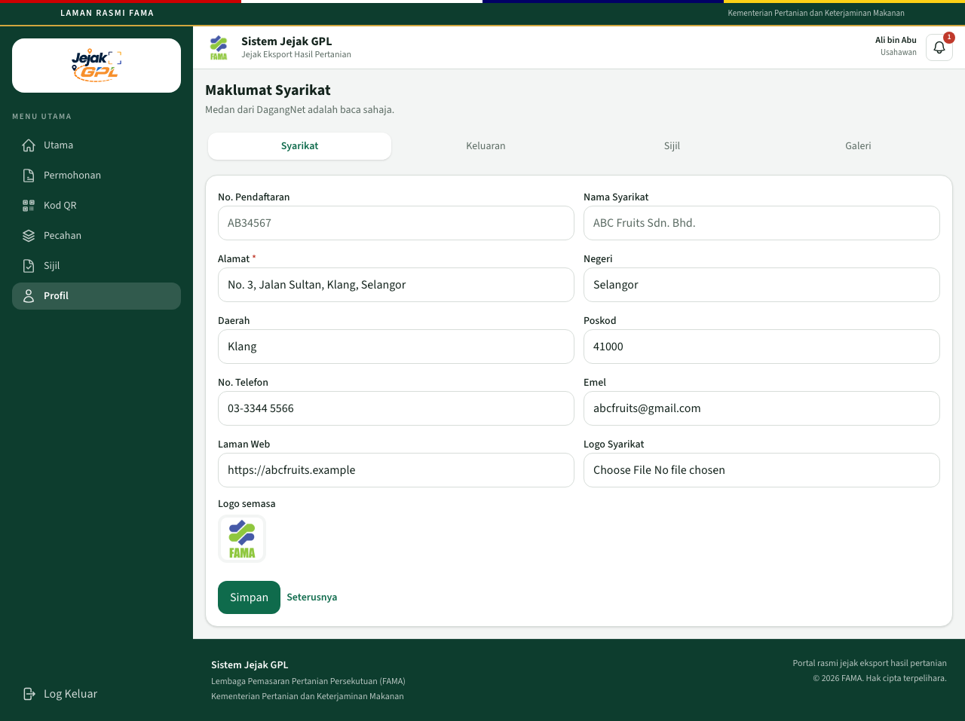
Maklumat Syarikat
No. Pendaftaran and Nama Syarikat come from DagangNet and stay read-only. The usahawan can update:
- Alamat, Negeri, Daerah, Poskod
- No. Telefon, Emel, Laman Web
- Logo Syarikat (JPG, PNG, or WEBP)
Click Simpan to keep the changes. Seterusnya moves to Keluaran.

Keluaran
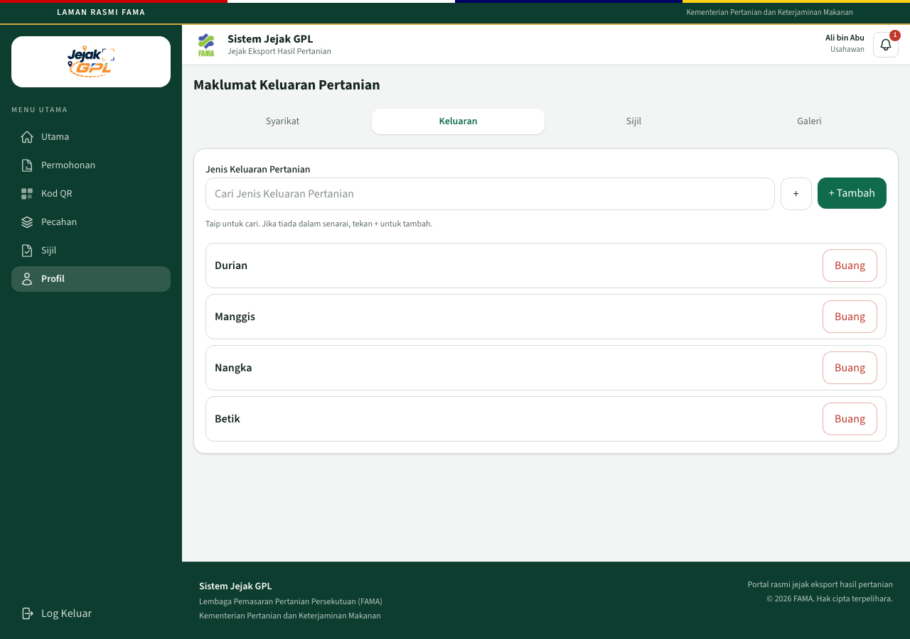
Maklumat Keluaran Pertanian
This is the list of produce the company exports. Type to search. If the name is not in the list, press + to add it, then + Tambah. Buang removes a row from the company list.

Sijil
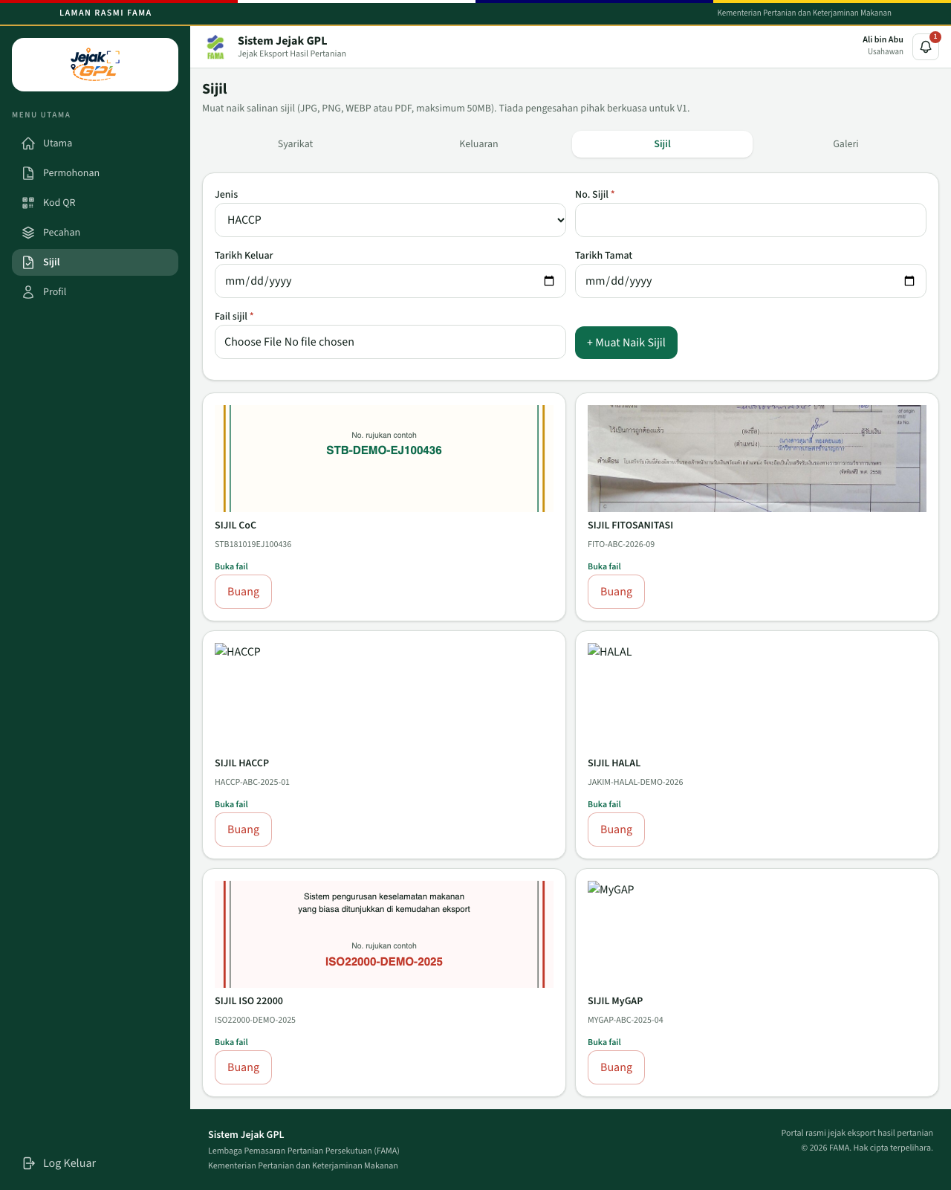
Sijil
Upload a copy of a certificate. Types are HACCP, MyGAP, CoC, FITOSANITASI, ISO 22000, and HALAL.
Field | Notes
Jenis | Certificate type
No. Sijil | Required
Tarikh Keluar / Tarikh Tamat | Optional
Fail sijil | JPG, PNG, WEBP, or PDF, maximum 50MB

Click + Muat Naik Sijil. Buka fail opens the uploaded file. Buang deletes that copy.
These are uploaded copies. This version does not call a certificate authority. A CoC uploaded here is what you later pick on an export application as No Sijil CoC.

Galeri
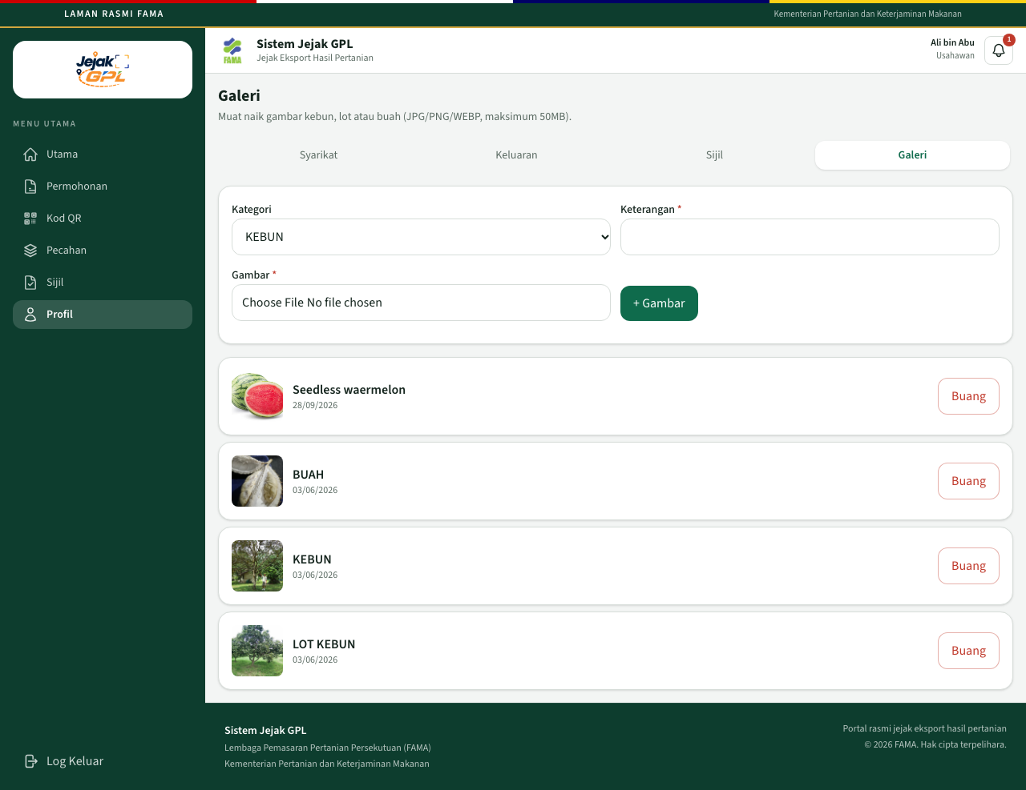
Galeri
Upload photos of the farm, the lot, or the fruit. Categories are KEBUN, LOT KEBUN, and BUAH. Add a Keterangan, choose a JPG, PNG, or WEBP up to 50MB, and click + Gambar.
Gallery photos support the company profile. The picture printed on a public QR is chosen later, on the application, as Gambar paparan QR.

6. Usahawan — applications
Open Permohonan.
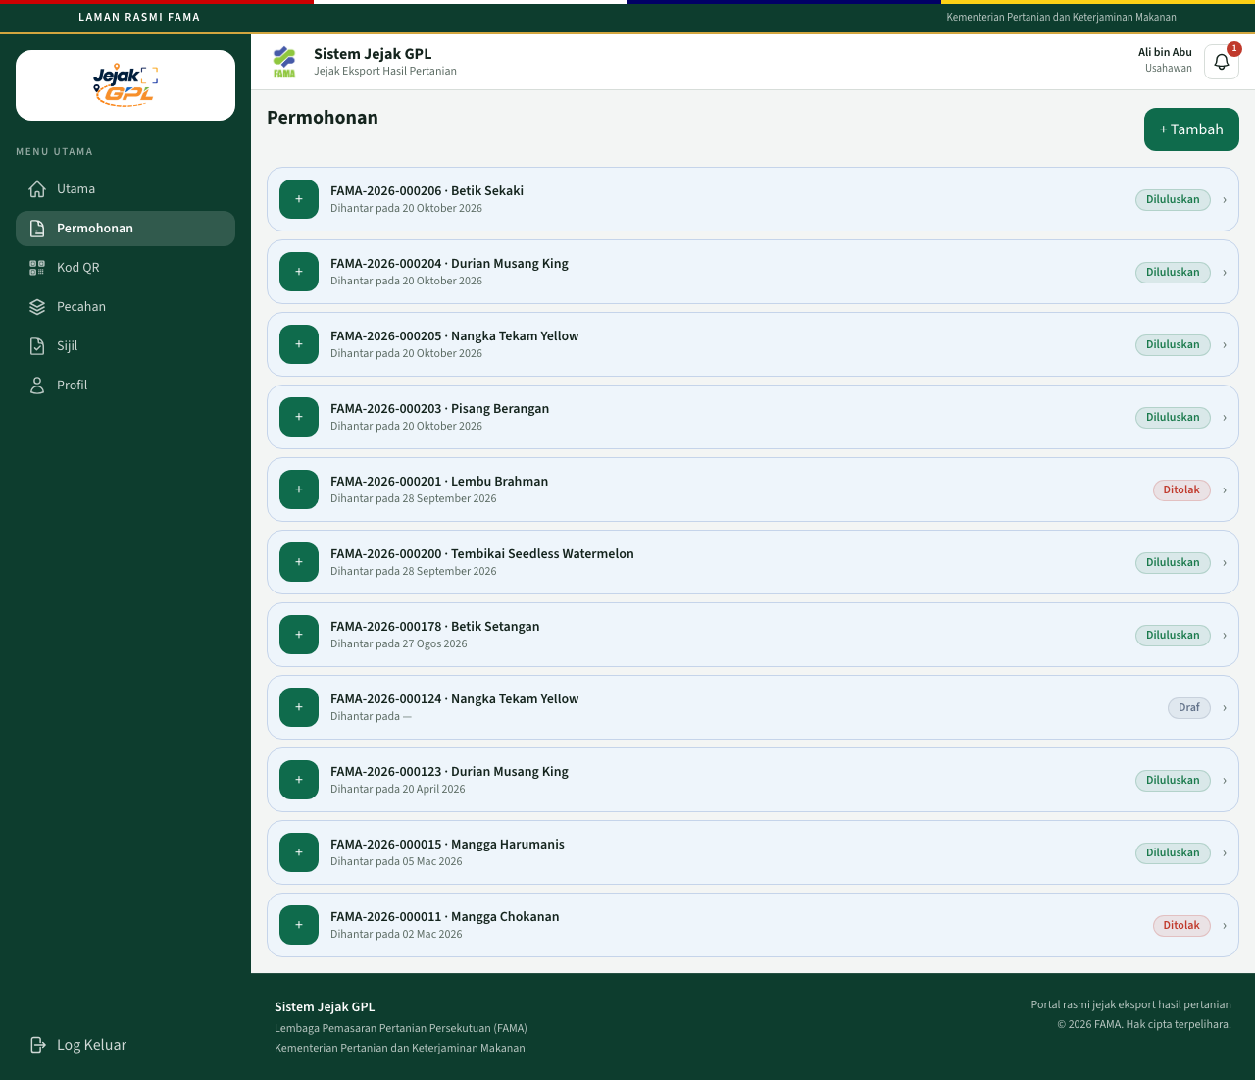
Senarai permohonan
Each row shows the application number, produce, variety, the date it was sent, and the status. + Tambah starts a new application.

Choose the kind of QR
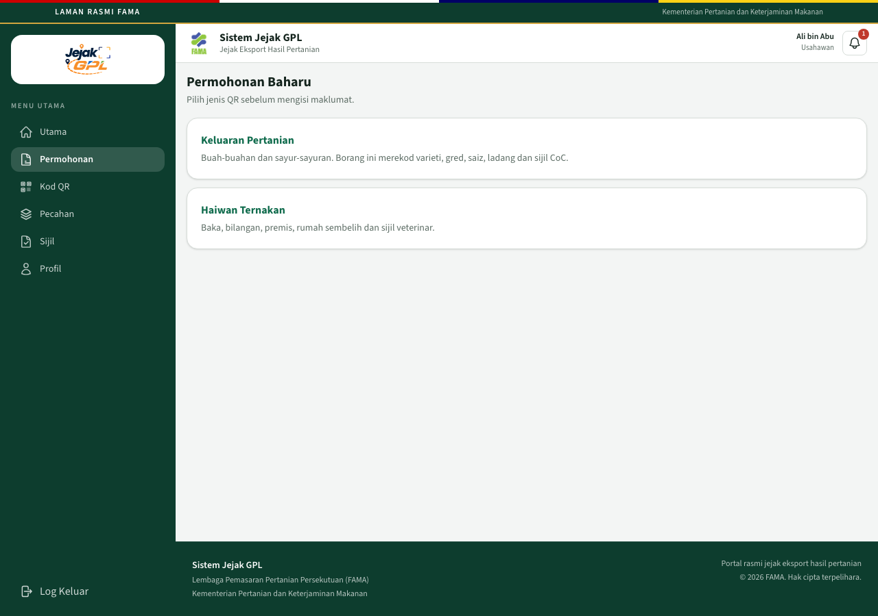
Pilih jenis permohonan
Choice | What you record
Keluaran Pertanian | Fruit and vegetables: variety, grade, size, farm, and CoC
Haiwan Ternakan | Breed, head count, premises, abattoir, and veterinary certificate

The page says an inactive QR is generated when the draft is saved.

Keluaran Pertanian
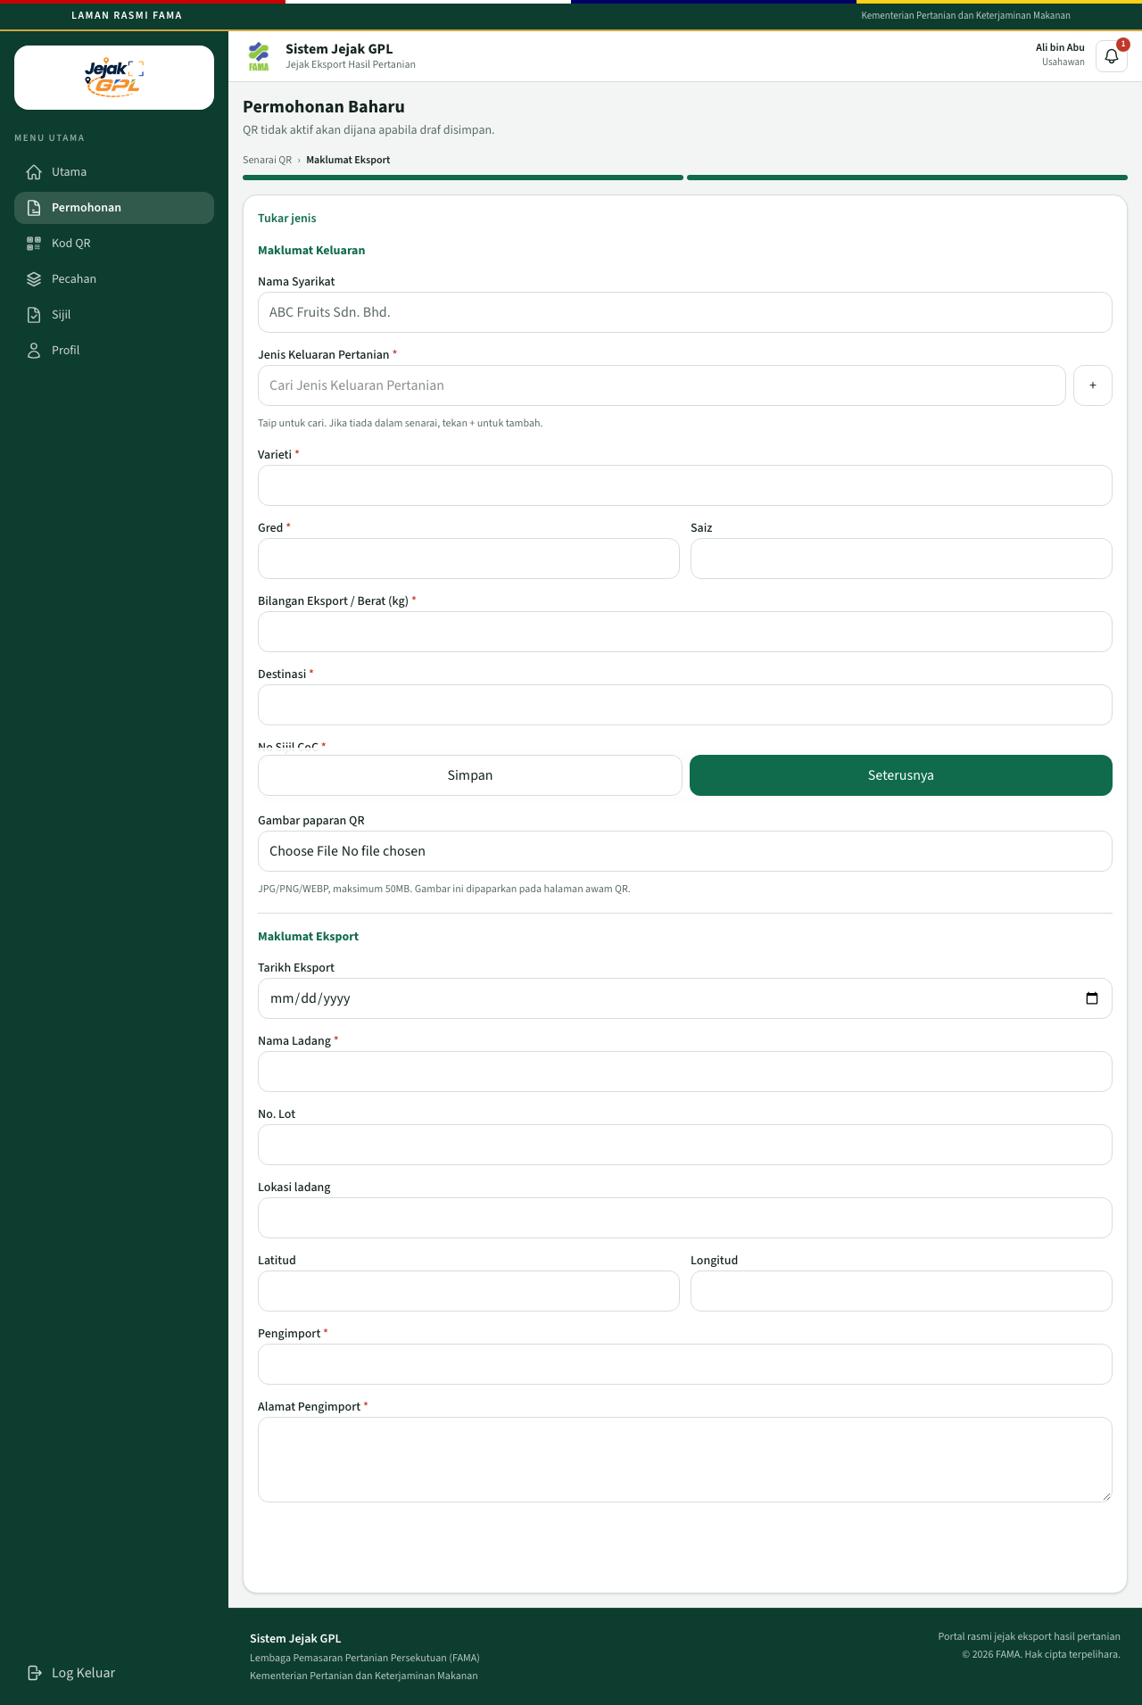
Borang keluaran pertanian
Simpan and Seterusnya stay on screen while you scroll. Both save the draft. Seterusnya is the main save on a new application.
Maklumat Keluaran
Field | Required | Notes
Nama Syarikat | — | Filled in, read-only
Jenis Keluaran Pertanian | Yes | Search, or press + to add a name
Varieti | Yes
Gred | Yes
Saiz | No
Bilangan Eksport / Berat (kg) | Yes | This quantity is the lot you can split later
Destinasi | Yes | Destination country
No Sijil CoC | Yes | Pick a CoC already uploaded under Sijil
Gambar paparan QR | No | JPG, PNG, or WEBP, maximum 50MB. This image is the one on the public page

Maklumat Eksport
Field | Required | Notes
Tarikh Eksport | No
Nama Ladang | Yes
No. Lot | No
Lokasi ladang | No
Latitud / Longitud | No | When both are saved, a map is shown. Click the map to move the pin. The coordinates update with the pin
Pengimport | Yes
Alamat Pengimport | Yes

Tukar jenis goes back to the choice between produce and livestock.

Haiwan Ternakan
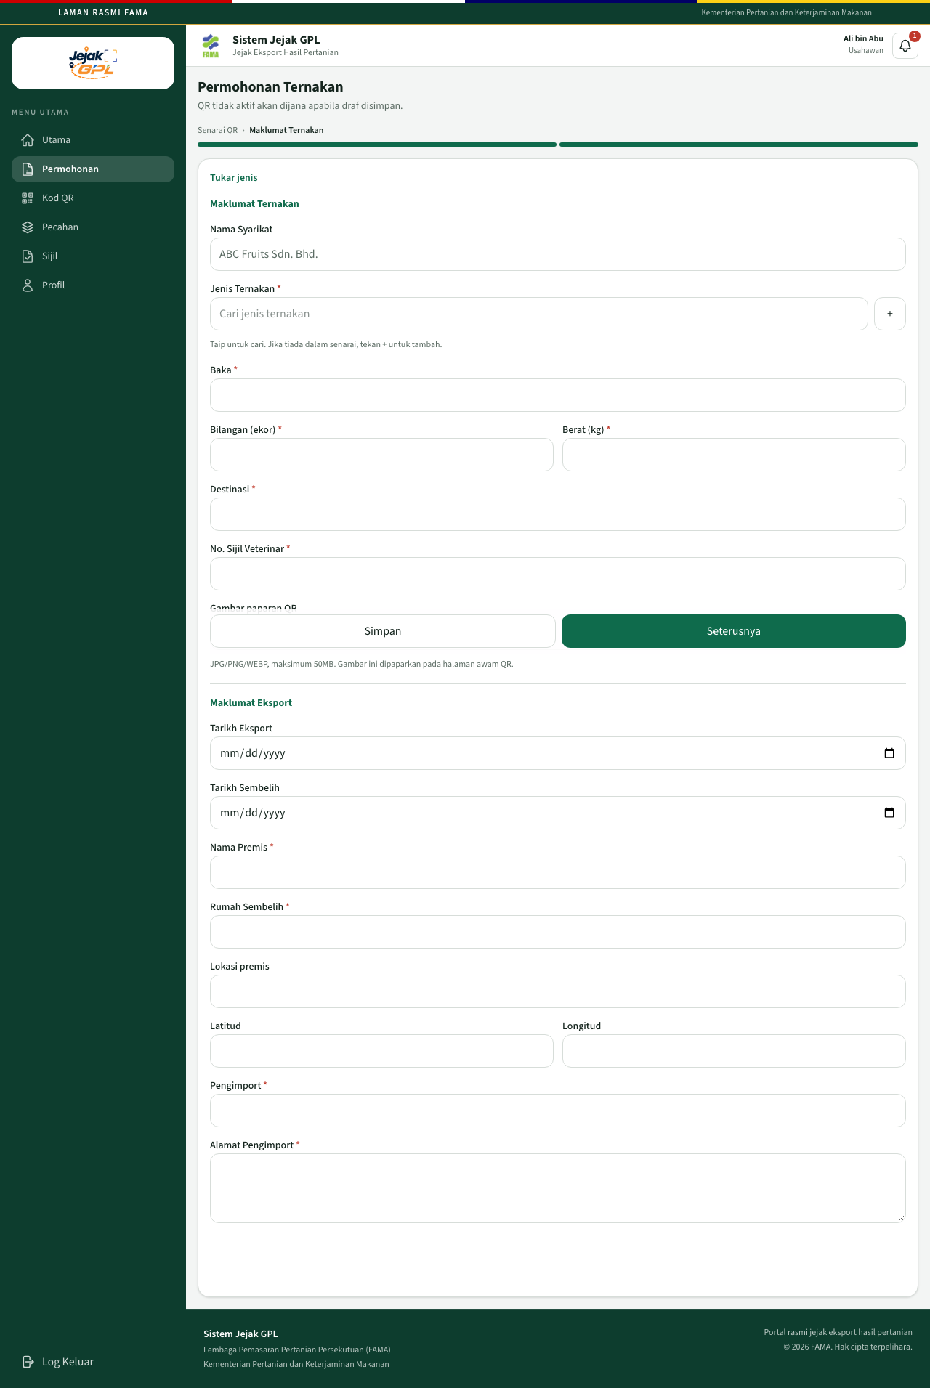
Borang ternakan
Maklumat Ternakan: Jenis Ternakan, Baka, Bilangan (ekor), Berat (kg), Destinasi, No. Sijil Veterinar, and an optional display image.
Maklumat Eksport: Tarikh Eksport, Tarikh Sembelih, Nama Premis, Rumah Sembelih, Lokasi premis, coordinates, Pengimport, and Alamat Pengimport.

After the draft is saved
You return to the application. Status is Draf. A Kod QR card appears with status Belum Aktif.
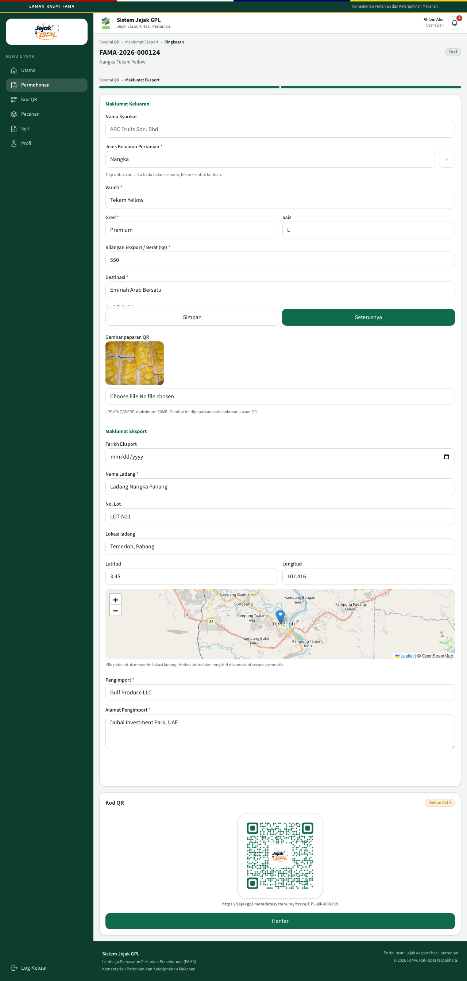
Draf with an inactive QR
While the status is Draf you can still edit the fields and click Simpan. Hantar sends the application to FAMA. After Hantar:
- The form locks.
- The status becomes Dihantar.
- The QR stays Belum Aktif.
Sending the application does not activate the QR. FAMA still has to approve it.
A draft that has no QR yet shows Jana QR. Saving the form normally creates the QR for you.

Approved application
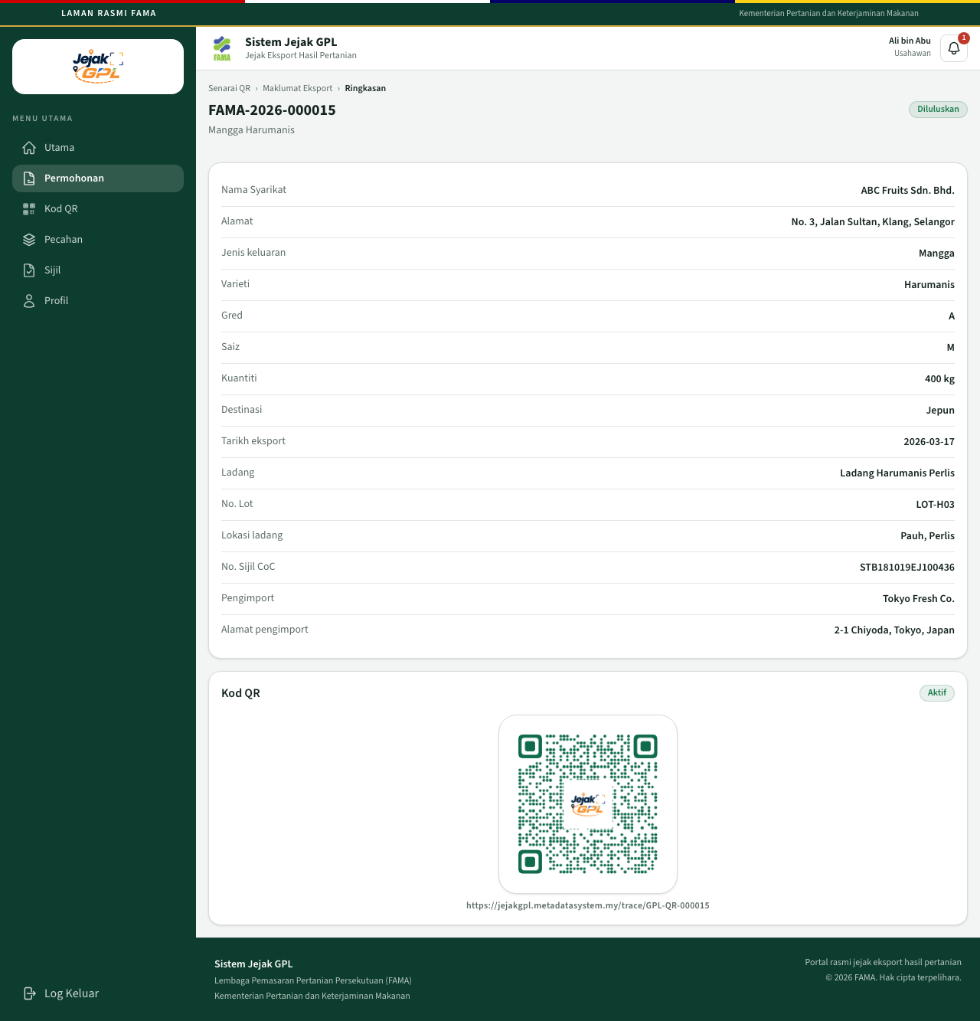
Permohonan diluluskan
Status Diluluskan. The QR badge is Aktif. The summary is read-only. The line under the title says the application is no longer a draft and cannot be edited.

Rejected application
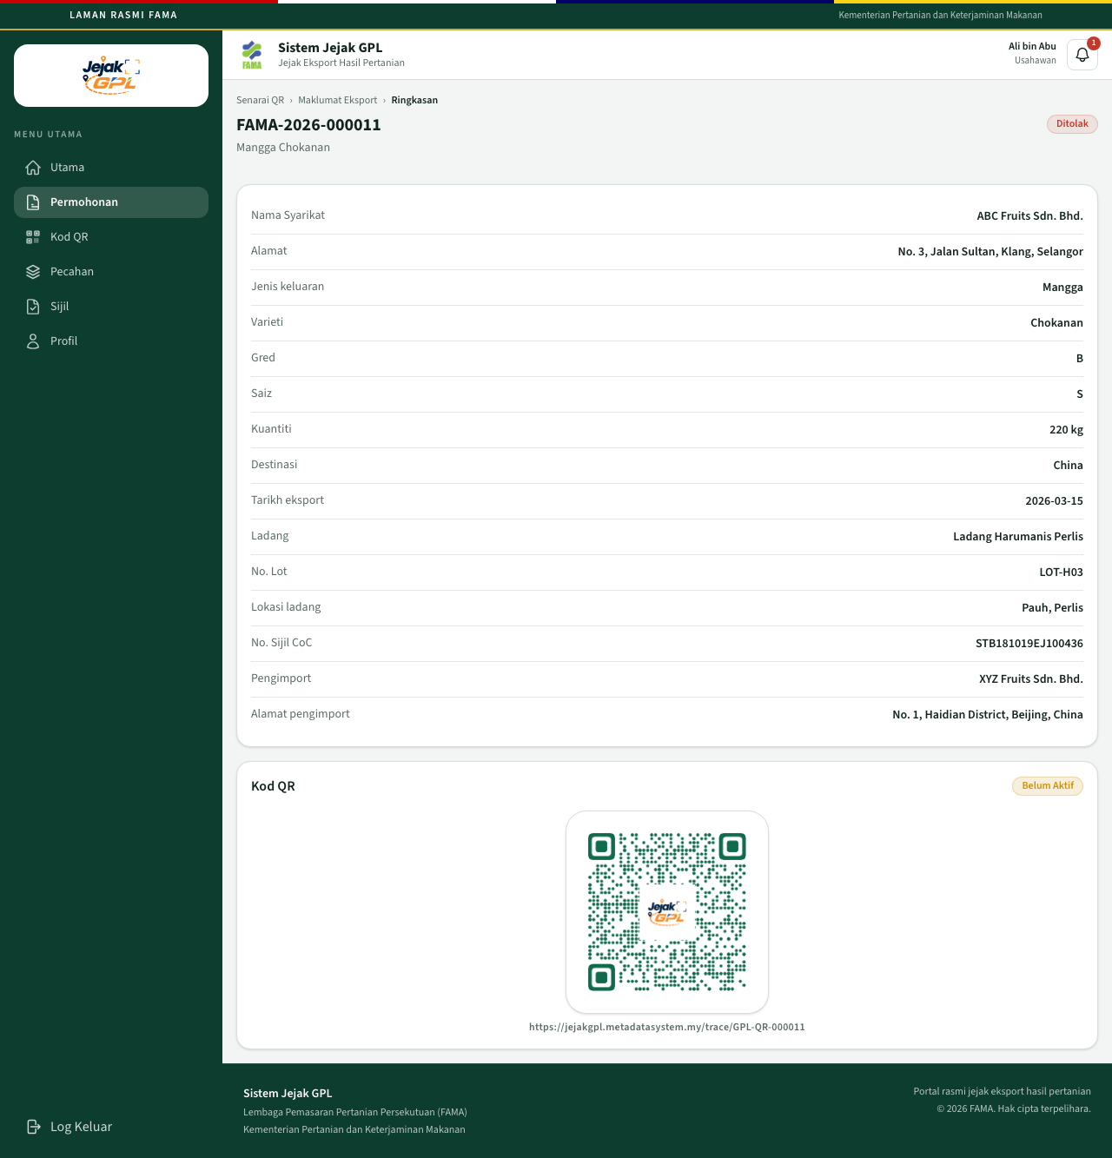
Permohonan ditolak
Status Ditolak. The QR stays Belum Aktif. The reason is stored with FAMA’s decision. A rejected application cannot be edited and sent again. File a new application if the export should be reviewed again.

7. Usahawan — QR codes
Open Kod QR.
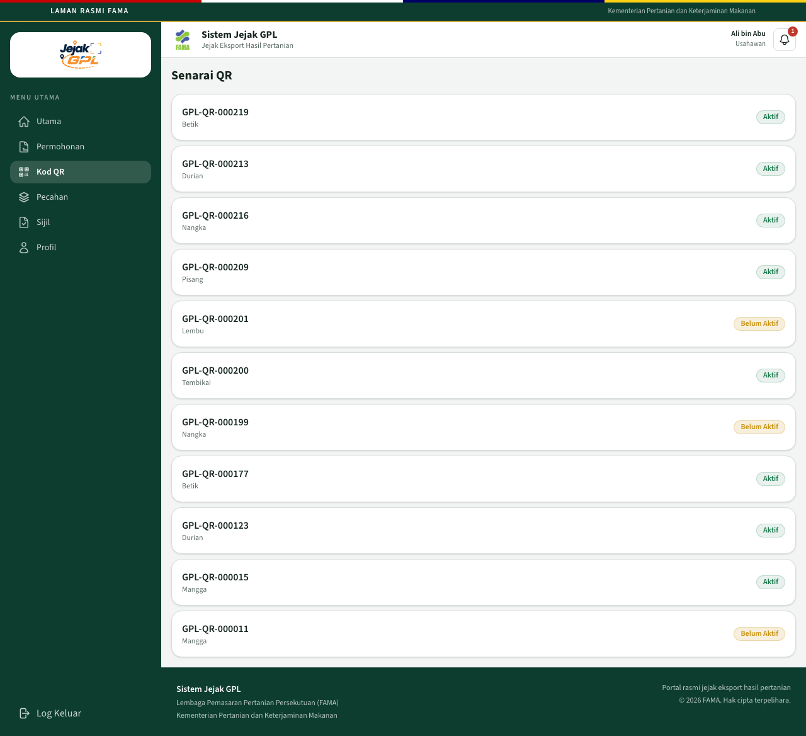
Senarai QR
Each row is a QR code, the produce, and Aktif or Belum Aktif. Open a row for the detail.
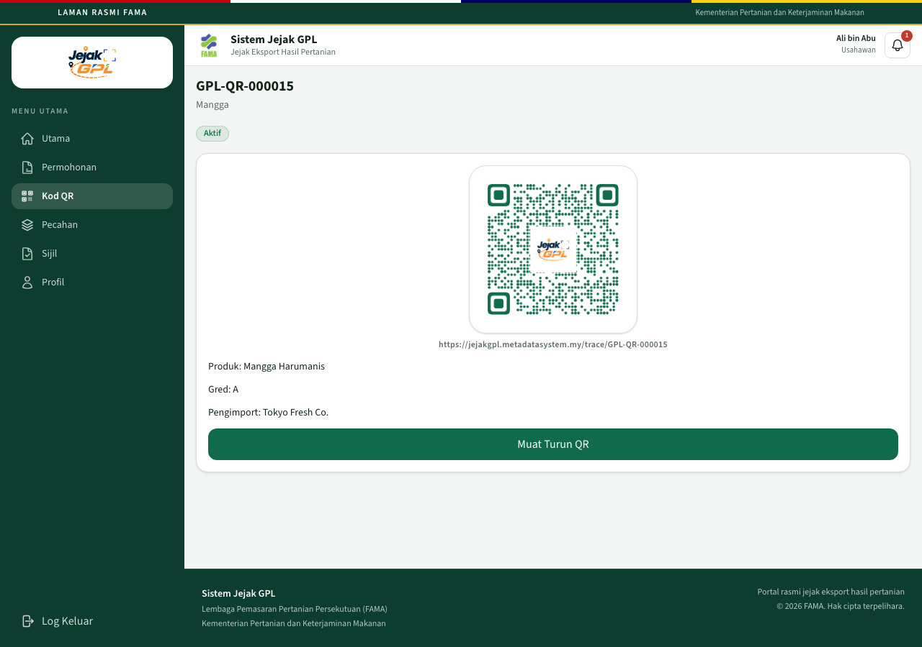
Butiran QR
The detail shows the public link, the product, the grade, the importer, and Muat Turun QR.
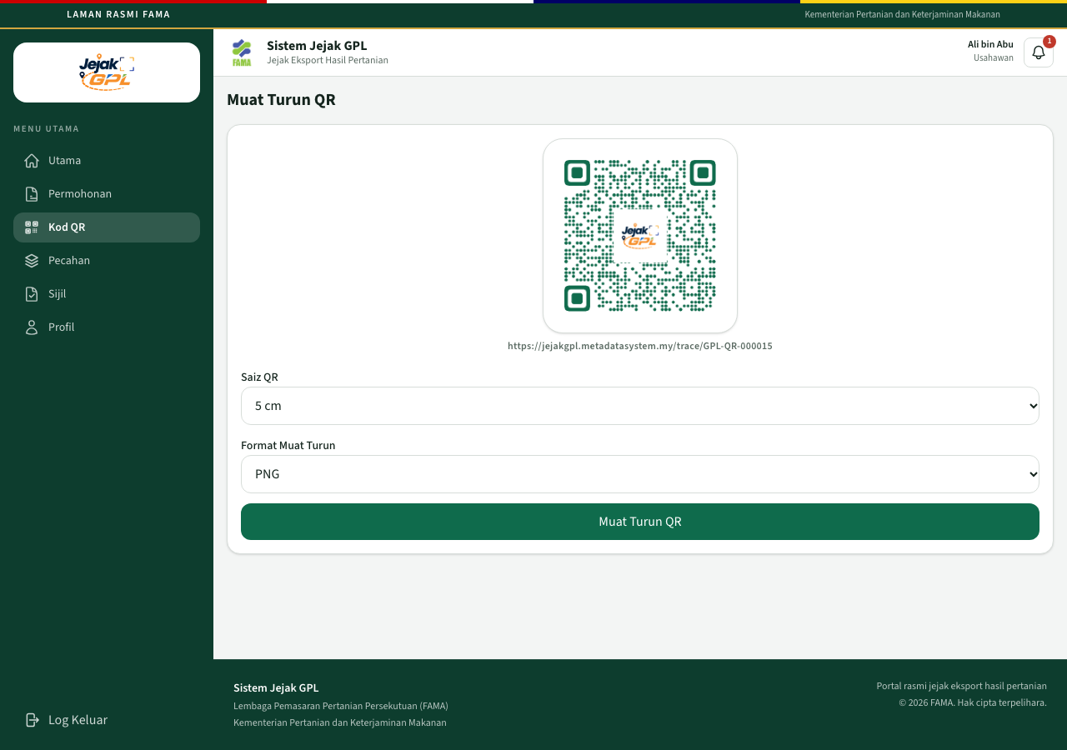
Muat turun QR
Option | Choices
Saiz QR | 3 cm, 5 cm, or Custom (8 cm)
Format Muat Turun | PNG or PDF

Click Muat Turun QR. The file encodes the same public address, for example https://jejakgpl.metadatasystem.my/trace/GPL-QR-000015. The size is for the label artwork. The system does not send the file to a printer.
You can download a QR that is still Belum Aktif. Scanning it before approval shows the inactive page, not the product page.

8. Usahawan — split a lot
The first QR is the whole shipment. Pecahan is where that shipment is broken into smaller lots. You do not file a new application for each box.
Open Pecahan.
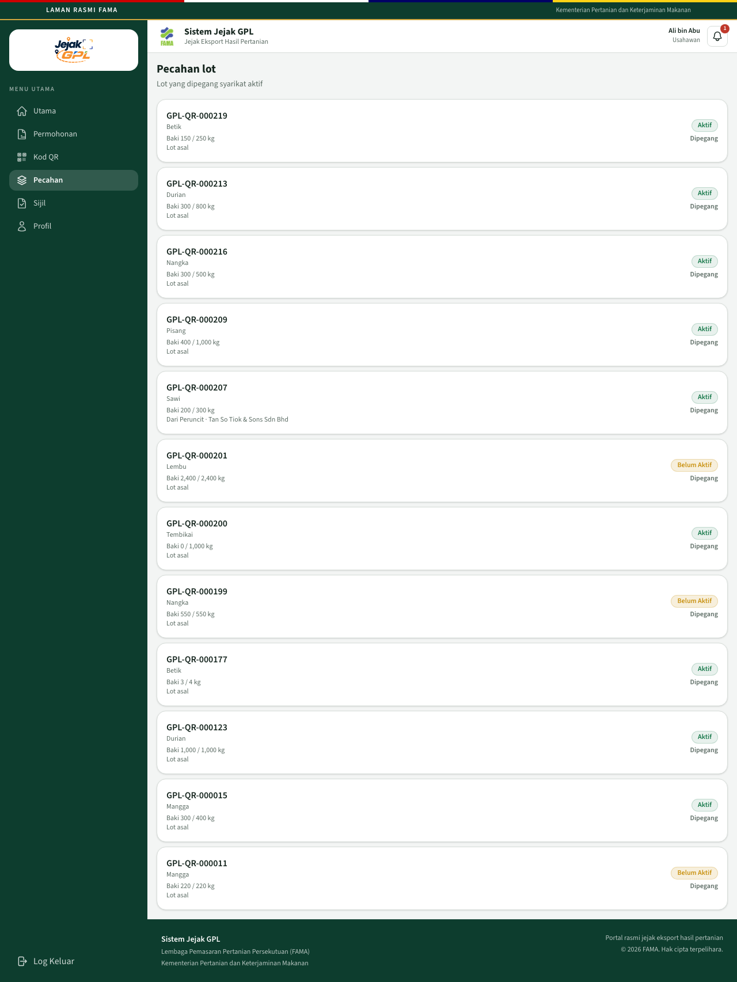
Senarai pecahan
A row shows the QR, the produce, Baki (what is left) against the original quantity, and whether it is the Lot asal or came from another company. Dipegang means the company still holds it. A QR that is Belum Aktif is listed, and it cannot be split until FAMA has approved it.
Open an active lot.
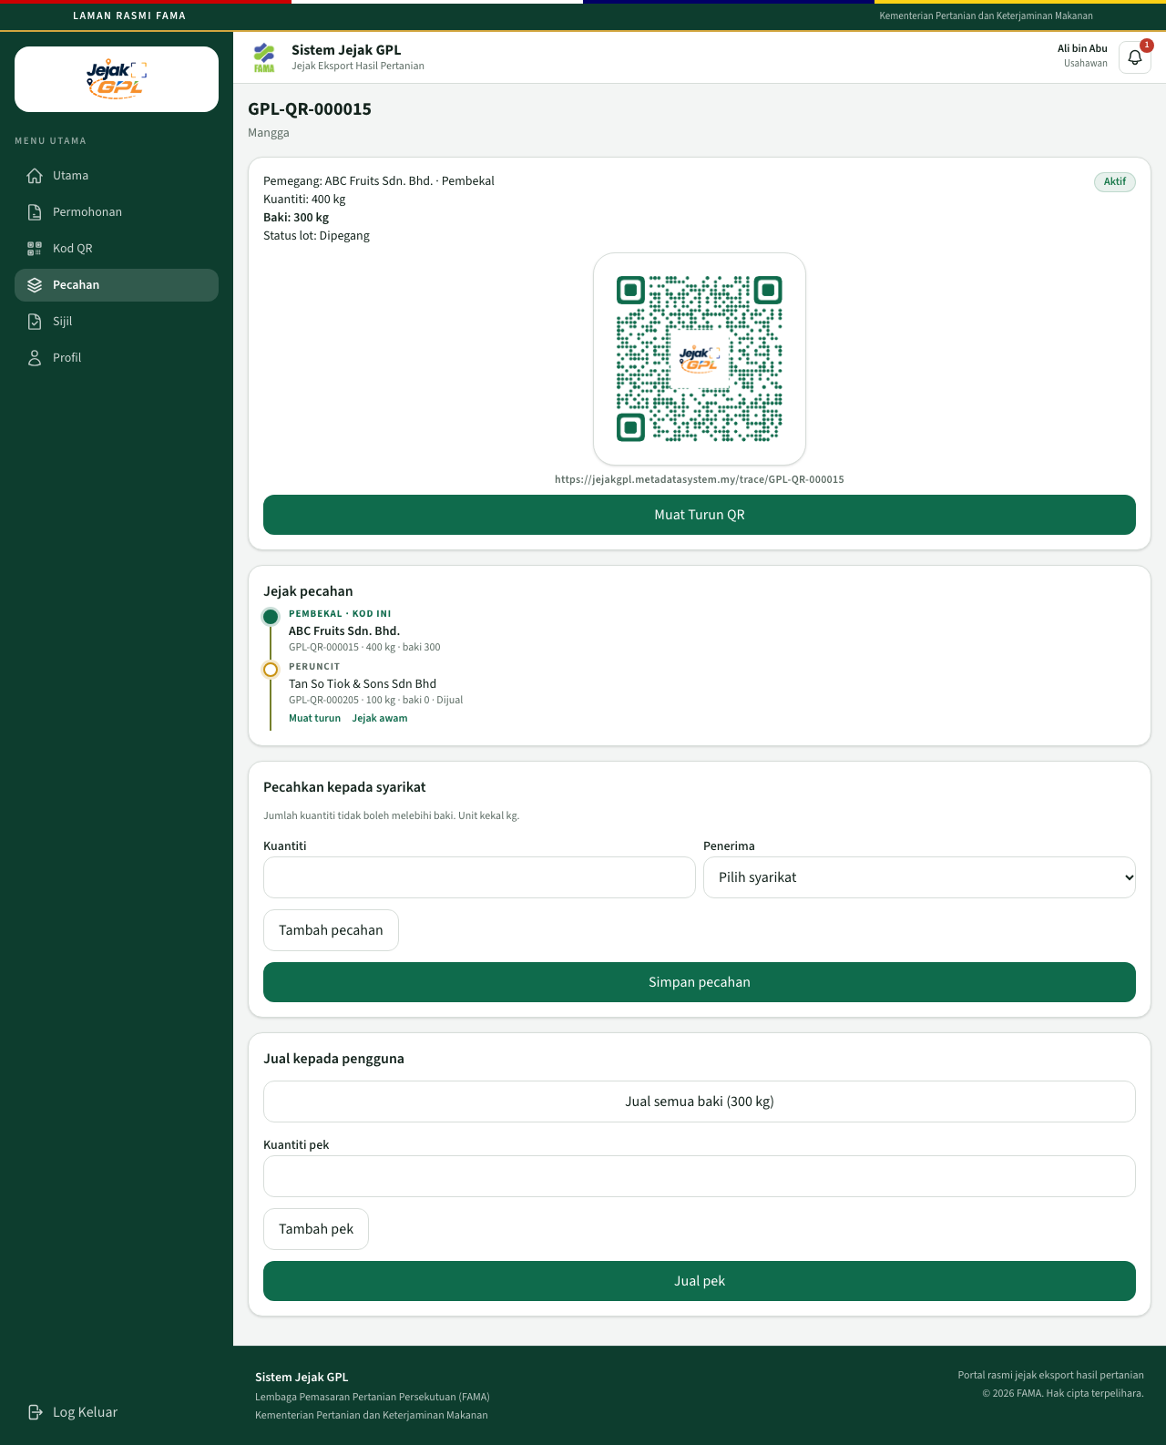
Pecahan satu lot
The card shows the holder, the chain role, the original quantity, the balance, and Status lot. Jejak pecahan is the line of companies. Kod ini marks the lot you are looking at. In the picture, ABC Fruits still holds the mango batch, and 100 kg has already moved to a retailer and been sold.

Give a quantity to another company
Under Pecahkan kepada syarikat:
- Kuantiti — kilograms, or the unit of that lot. The pieces together cannot exceed Baki.
- Penerima — the company that should hold the next stop. The list shows that company’s chain role and name.
- Tambah pecahan adds another row, so one save can create several pieces.
- Simpan pecahan.
The page confirms the split. Your balance drops. Each new QR is Belum Aktif and labelled Menunggu penerimaan until that company accepts it. You can still Muat turun the new QR and hand the label over. The new code is not in the recipient’s Pecahan list until they accept it.

The recipient accepts
- The recipient signs in as USAHAWAN.
- Under Kod QR, the new code is listed as waiting.
- They open Jejak awam for that QR, or open the public link while they are signed in.
That visit accepts the lot. The public page then shows the product, and Jejak pecahan marks their stop as Kod ini. The QR becomes Aktif. They can split only the quantity they accepted.
Before acceptance, a visitor who is not signed in as that company sees QR Menunggu Penerimaan. The product page stays hidden. The message asks the receiving company to sign in and open the link again.

Sell to a consumer
Jual kepada pengguna is a sale with no company login on the new code.
- Jual semua baki marks this whole QR as sold and blocks further splits.
- Jual pek creates a consumer QR for each quantity you type. Tambah pek adds another pack. A consumer QR is active immediately. The chain ends at Consumer.
Only the company that currently holds the lot can split or sell it. Another company’s login shows that the current holder must do it.

9. Usahawan — audit trail
The audit trail is not in the left menu. Open:
https://jejakgpl.metadatasystem.my/exporter/audit
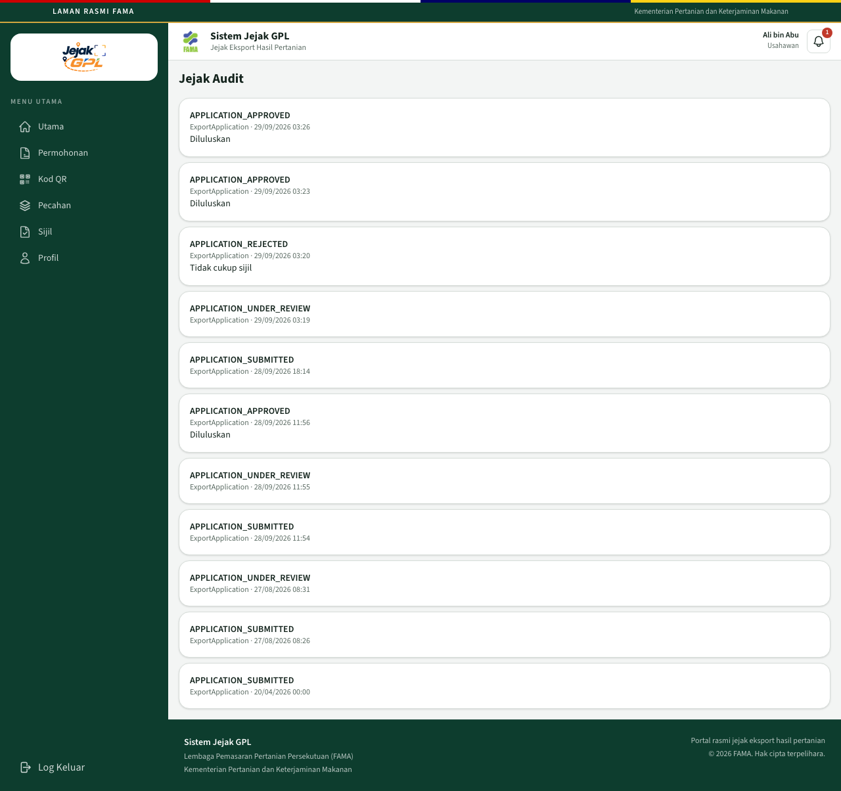
Jejak audit usahawan
Each row is an action, the record type, the date and time, and a remark when one was stored. Actions you will see include:
Action | When it is written
QR_GENERATED | A QR is created with a draft
APPLICATION_SUBMITTED | The usahawan clicks Hantar
APPLICATION_UNDER_REVIEW | An officer opens a submitted application
APPLICATION_APPROVED | The officer clicks Sahkan
APPLICATION_REJECTED | The officer clicks Tolak
LOT_SPLIT | A lot is split
LOT_ACCEPTED | The receiving company opens the public link and accepts the lot

10. Pegawai FAMA — monitoring
Sign in with the role set to FAMA. The home page is Utama FAMA.
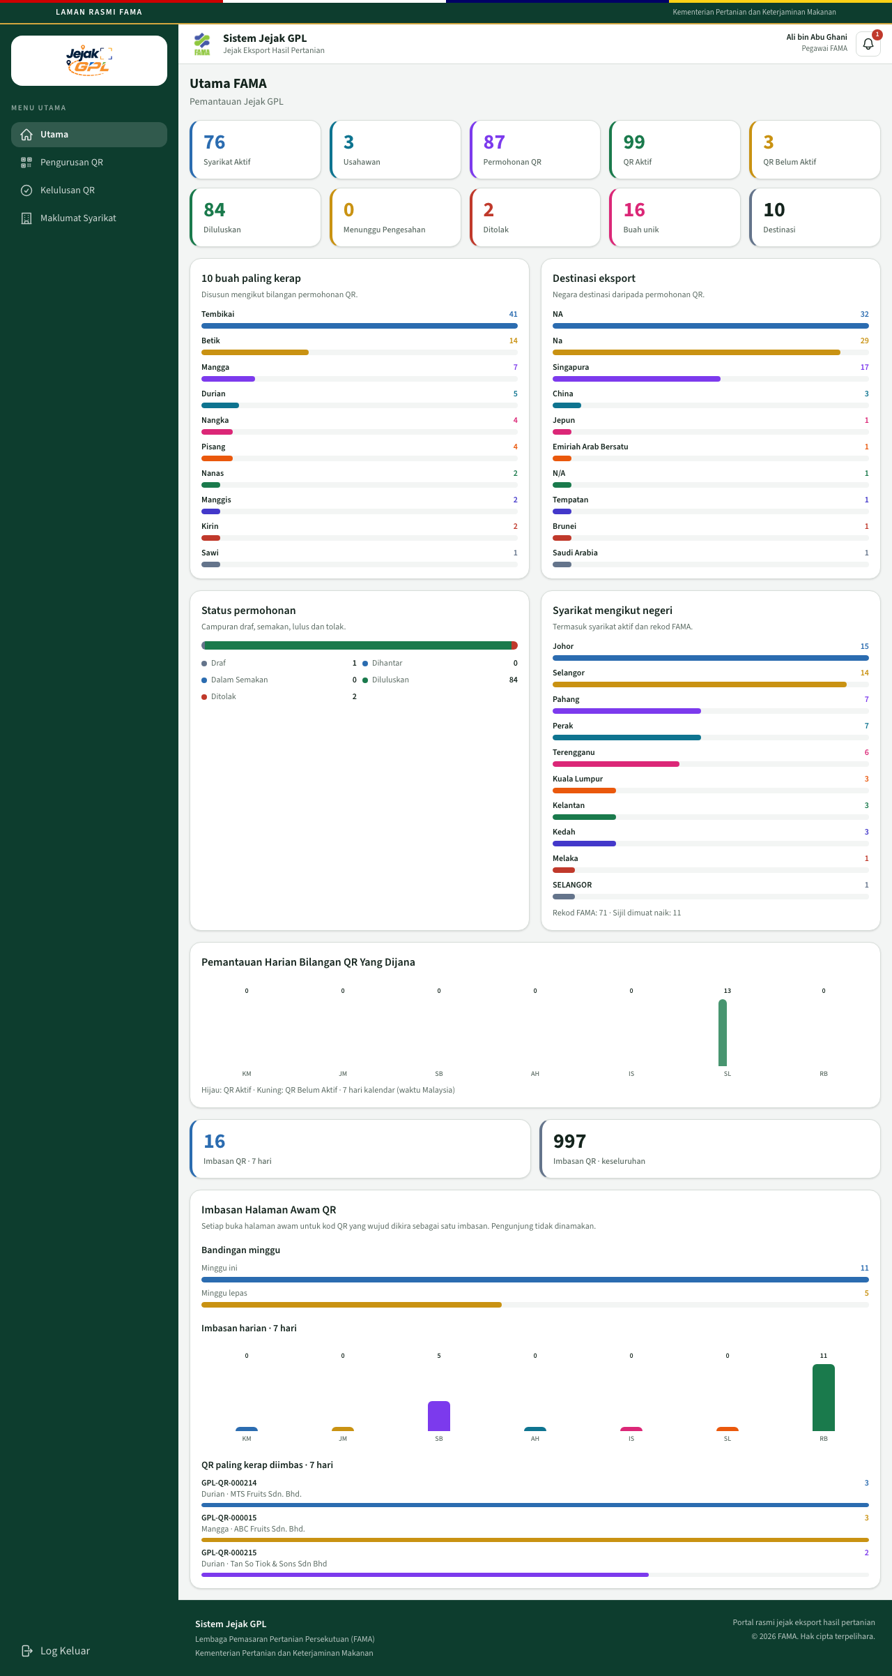
Utama FAMA
The tiles count companies, usahawan accounts, applications, active and inactive QR codes, approvals, rejections, and what is waiting. Menunggu Pengesahan opens the queue of applications still in review.
Below the tiles:
Panel | What it shows
10 buah paling kerap | Produce with the most QR applications
Destinasi eksport | Destination countries
Status permohonan | Mix of draft, sent, in review, approved, and rejected
Syarikat mengikut negeri | Companies by state, including FAMA-managed records
Pemantauan Harian Bilangan QR Yang Dijana | QR codes created over the last 7 days. Green is Aktif. Yellow is Belum Aktif
Imbasan QR | Opens of a real public QR page in the last 7 days, and the overall total
Imbasan Halaman Awam QR | The same scans as a chart, plus the QR codes opened most often

Each open of a real public page counts as one scan. Visitors are not named.
The left menu:
- Utama
- Pengurusan QR
- Kelulusan QR
- Maklumat Syarikat

Pengurusan QR
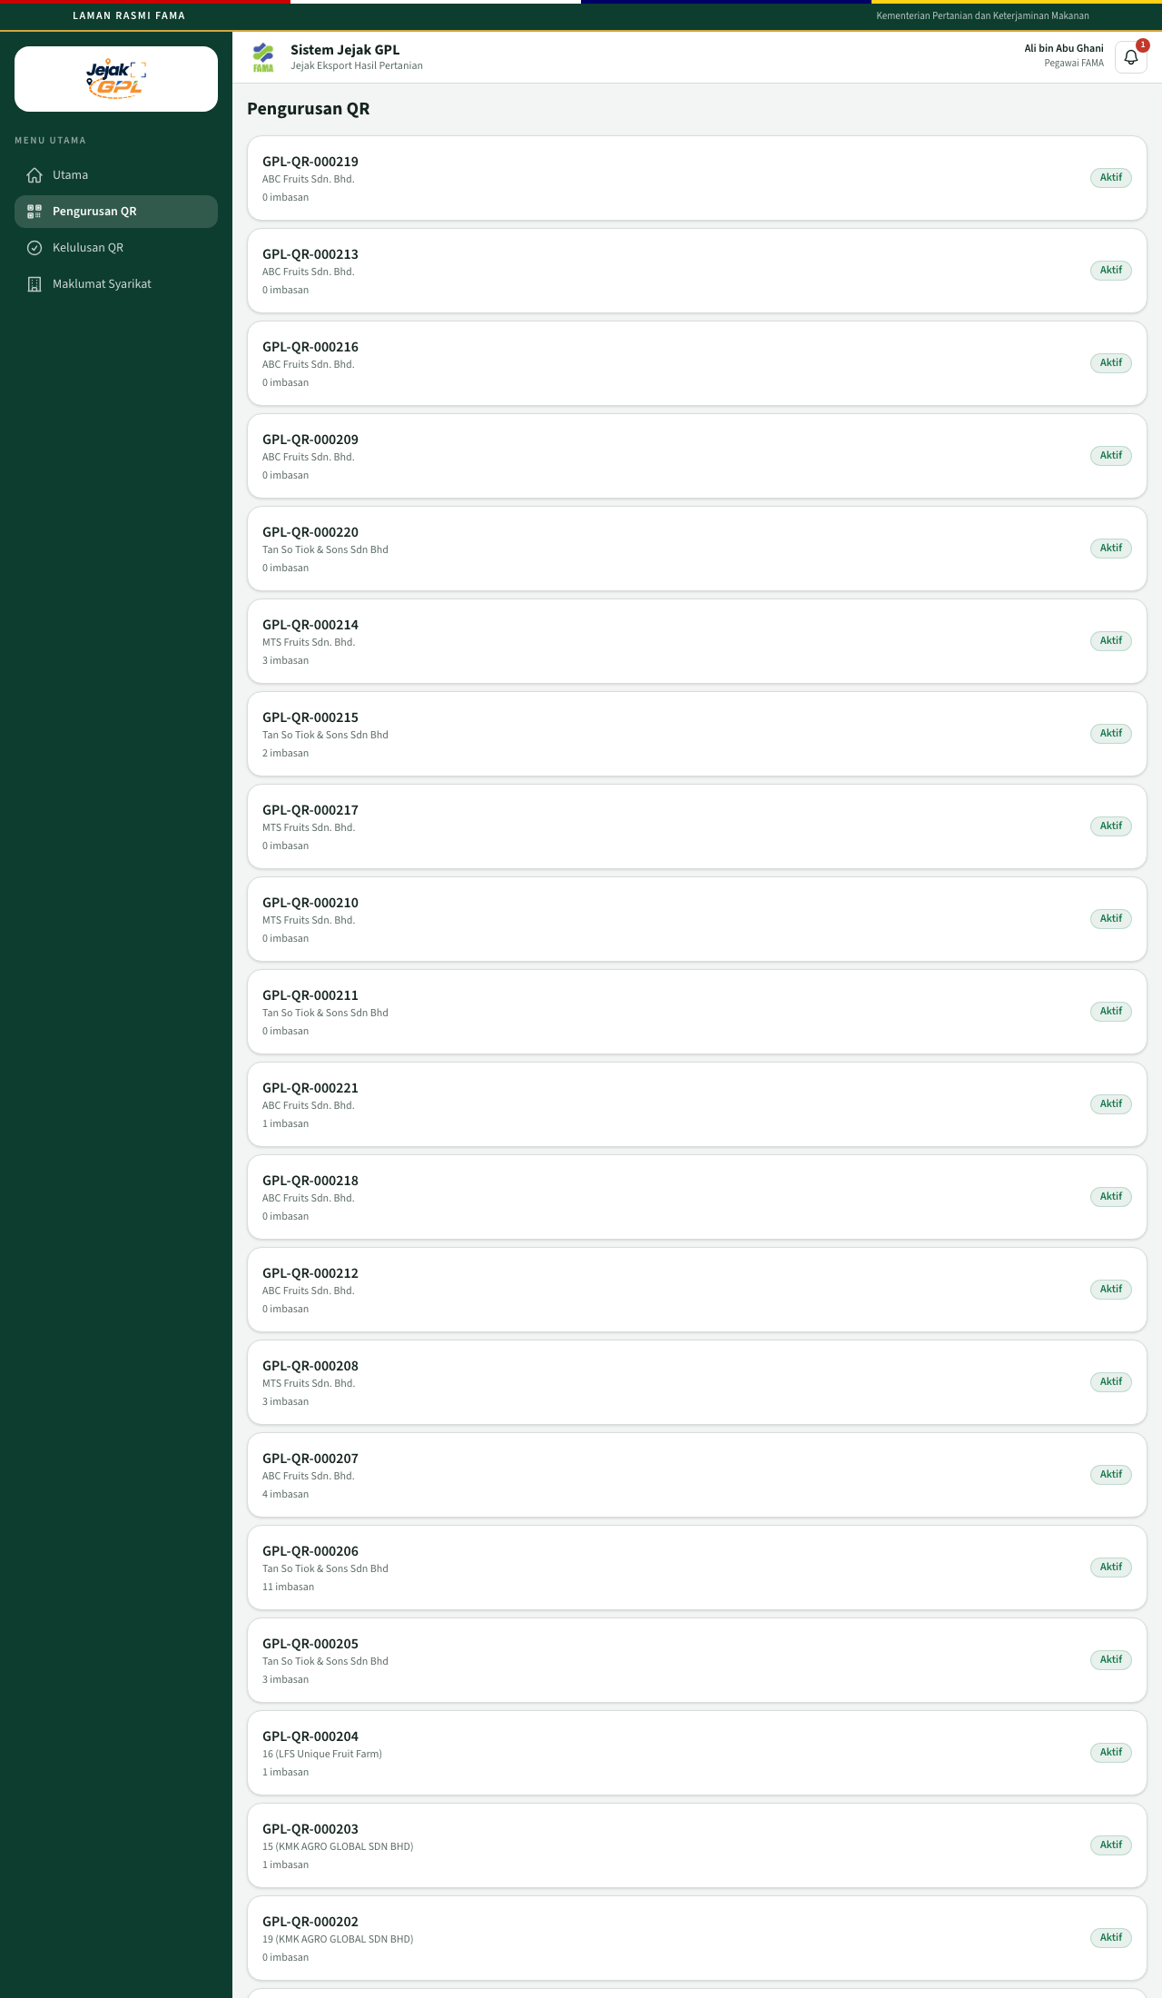
Pengurusan QR
Every QR is listed with the holder, the number of public scans, and Aktif or Belum Aktif. Opening a row goes to that application’s summary.

11. Pegawai FAMA — review and decision
Open Kelulusan QR.
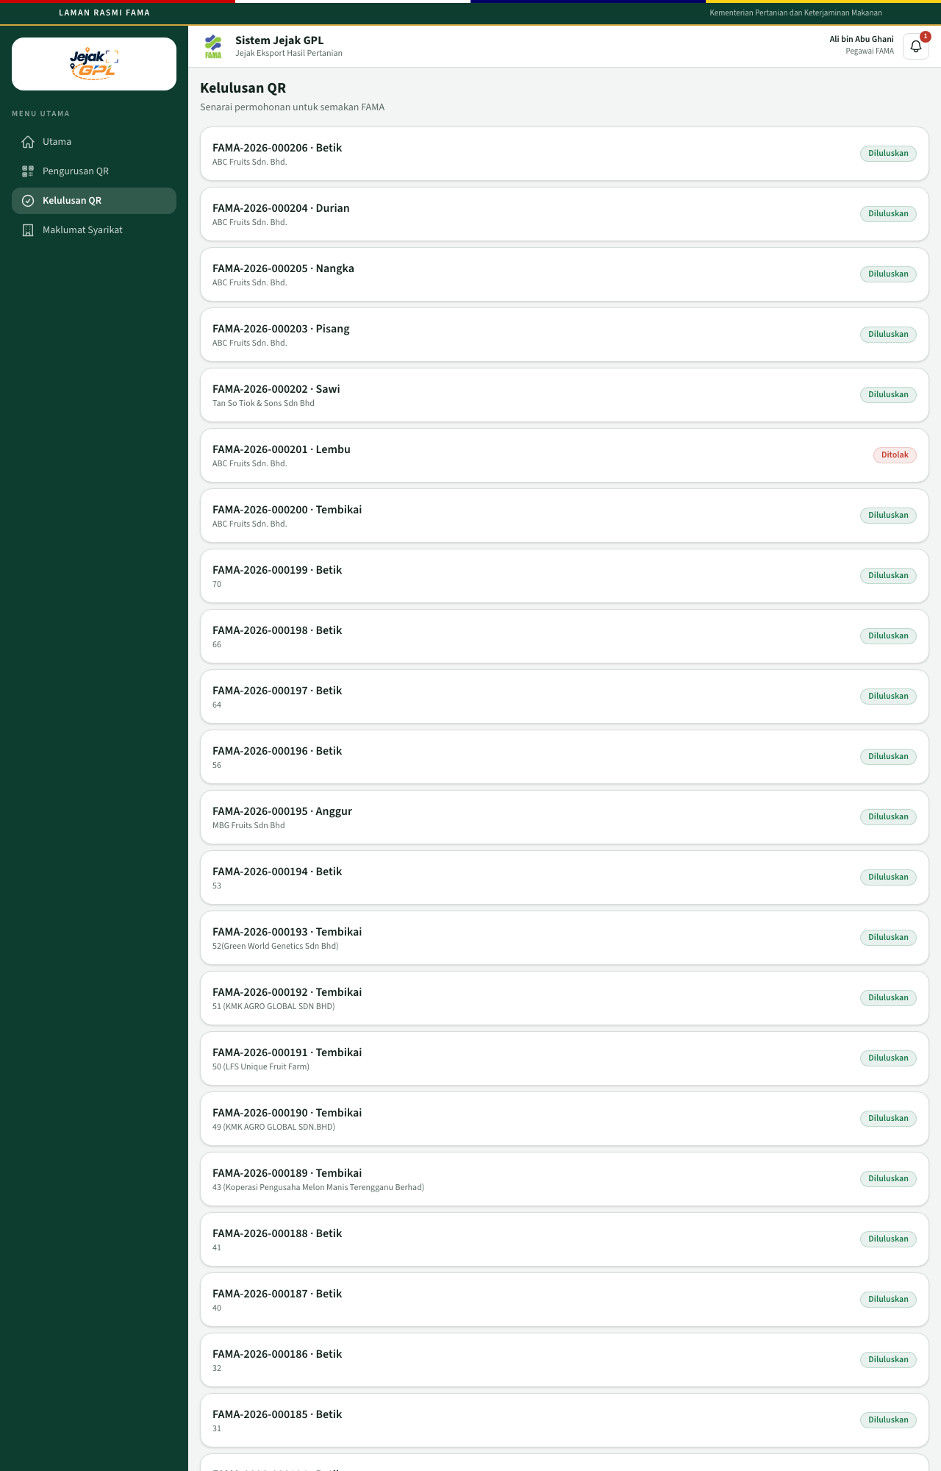
Kelulusan QR
The list is every application FAMA can see: company, produce, and status. Open the row you want to review.
Opening an application that is Dihantar moves it to Dalam Semakan by itself. You do not click a separate “start review” button.
On a record that is still Dihantar or Dalam Semakan, the summary shows the product, company, farm, importer, and CoC number, plus the QR. Under that:
- Catatan — required when you reject. The placeholder says it is required if you reject.
- Tolak — rejects the application. An empty note shows Catatan penolakan diperlukan.
- Sahkan — approves it. You do not have to type a note. The system stores Diluluskan.
Approval and QR activation are one step. The officer does not activate the QR separately. The badge becomes Diluluskan and the QR becomes Aktif.
Rejection sets the status to Ditolak and leaves the QR Belum Aktif. The reason is kept on the decision.
After a decision, Sahkan and Tolak are no longer shown. Keputusan shows the outcome.
An approved record:
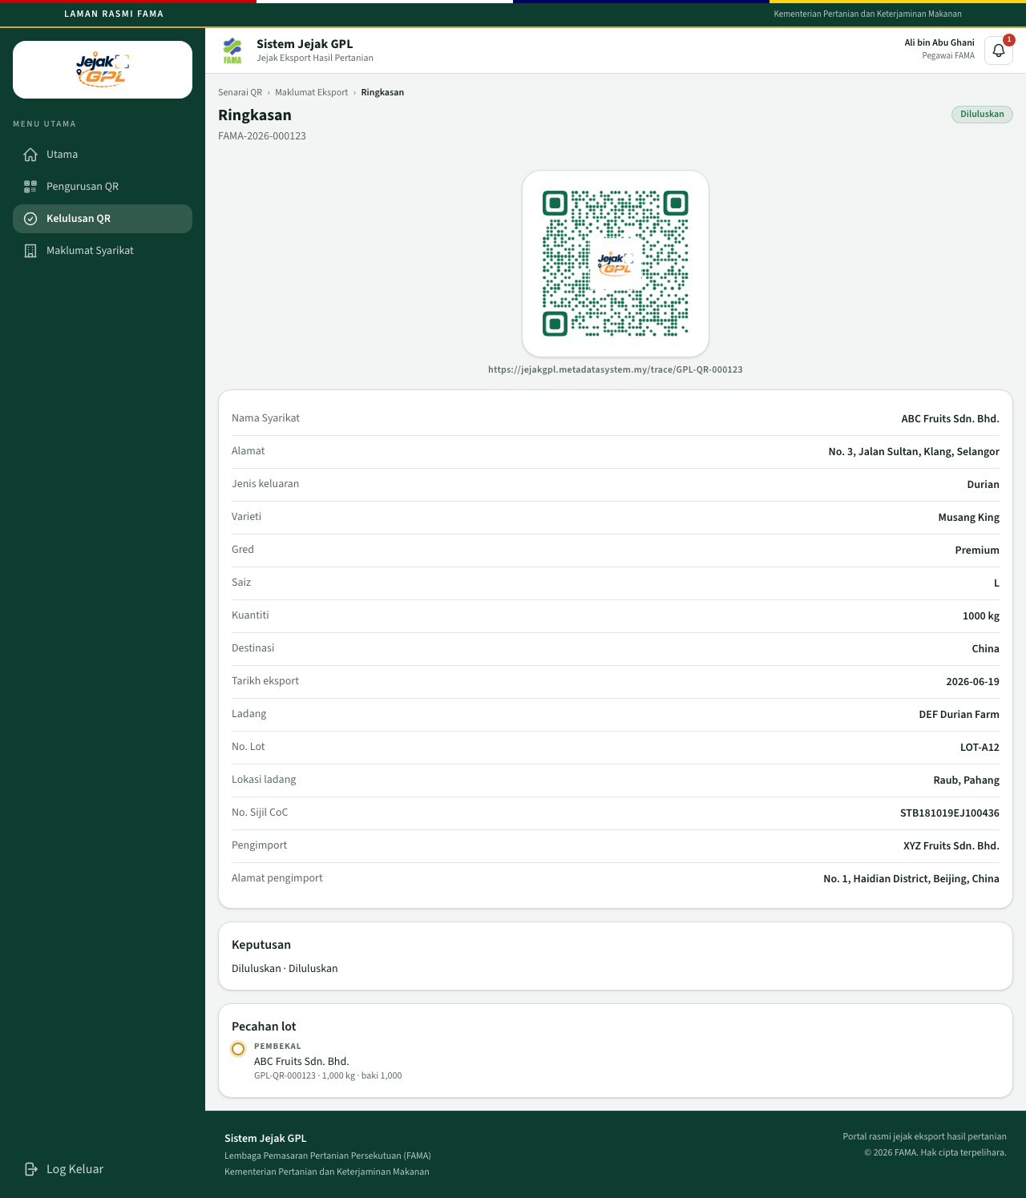
Ringkasan diluluskan
A rejected record, with the officer’s note:
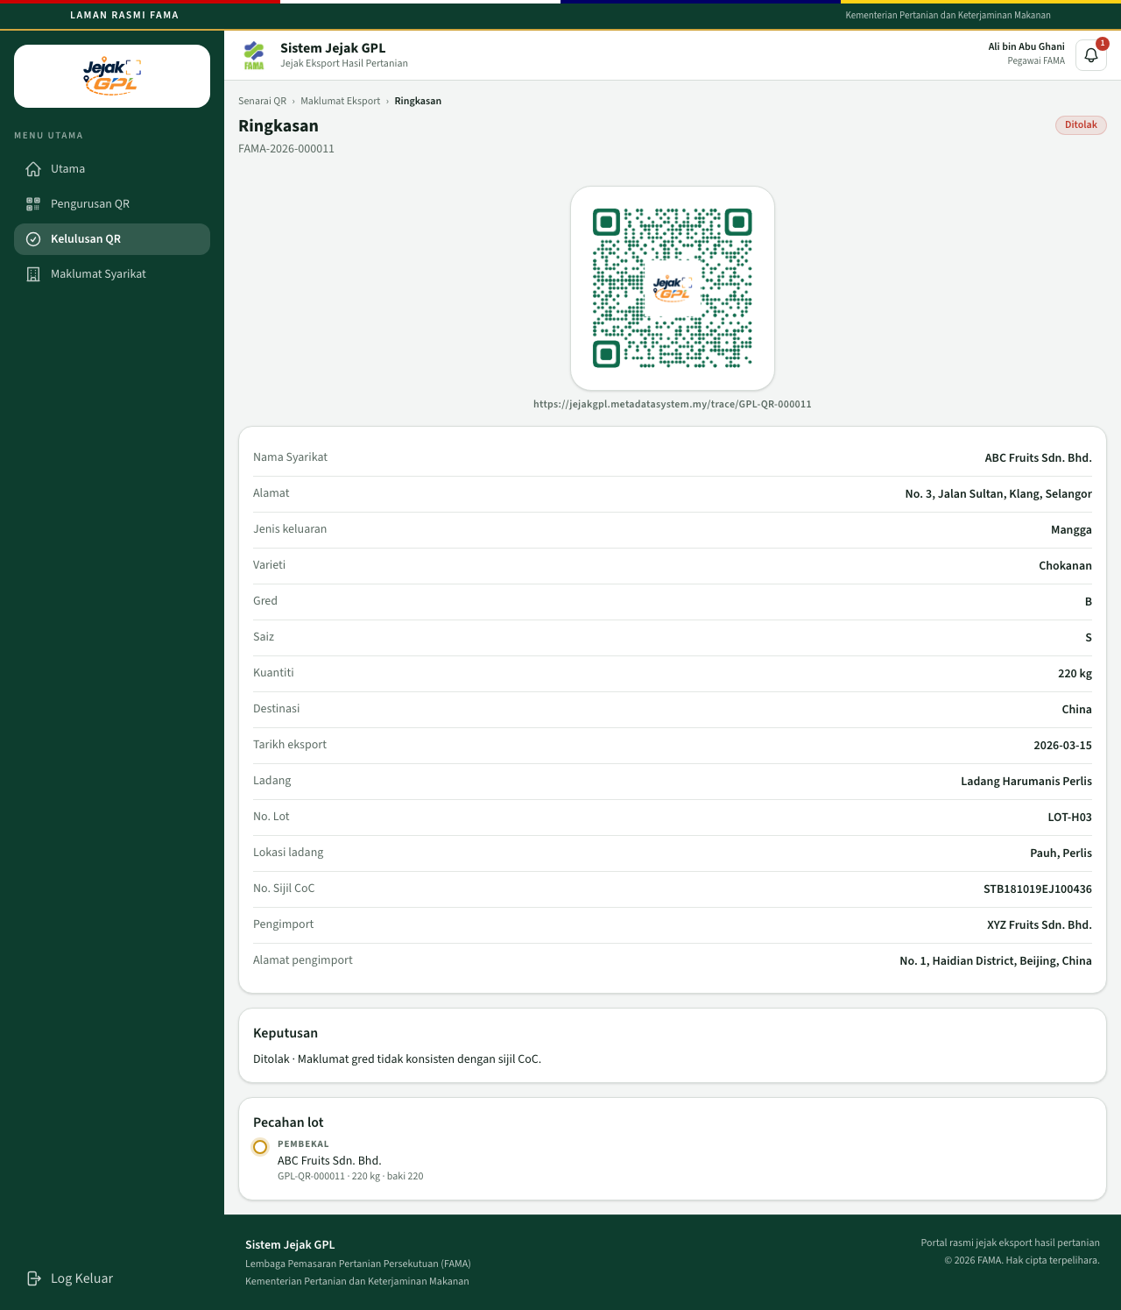
Ringkasan ditolak
Pecahan lot on the same page uses the same chain as the usahawan’s lot screen: the original batch, then each piece, with the balance. Before the next company accepts, that piece says Menunggu penerimaan. FAMA can see where the batch went. The officer does not accept the lot for the holder.

12. Pegawai FAMA — companies and direct QR
Open Maklumat Syarikat.
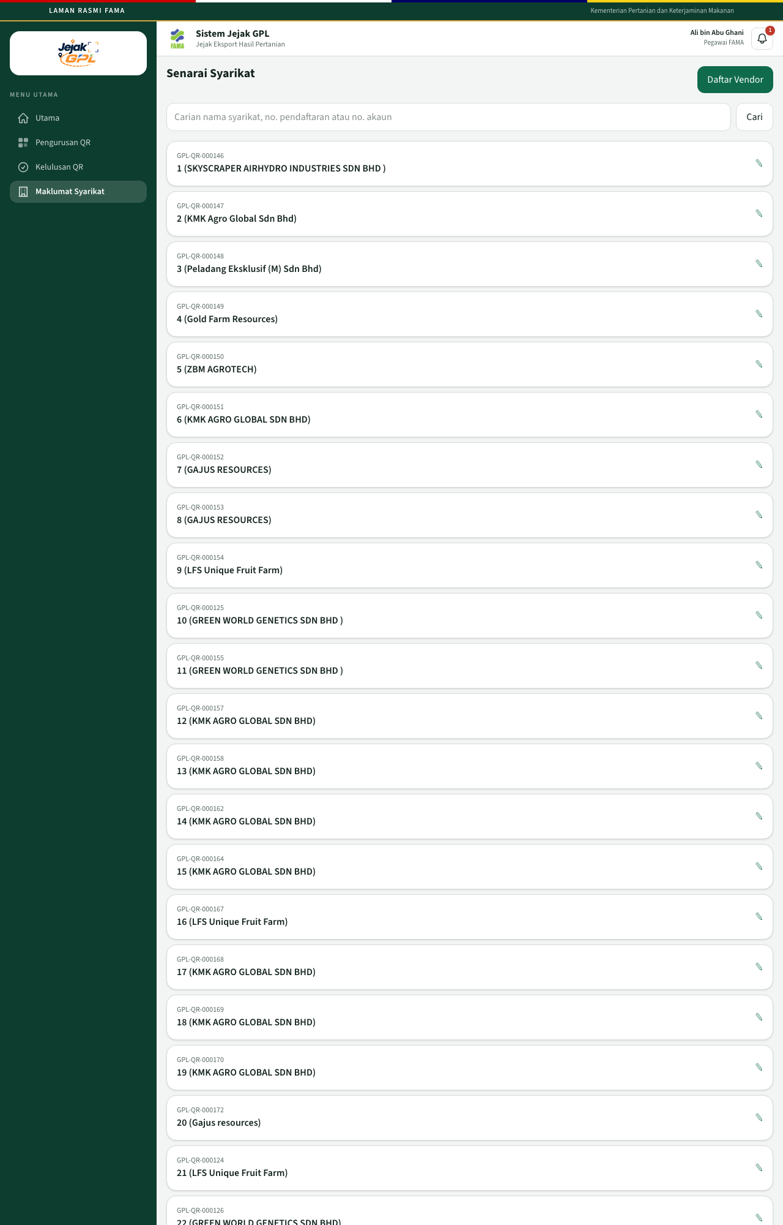
Senarai syarikat
Search by company name, registration number, or account number, then click Cari. The search also runs as you type. Open a company to see its file.
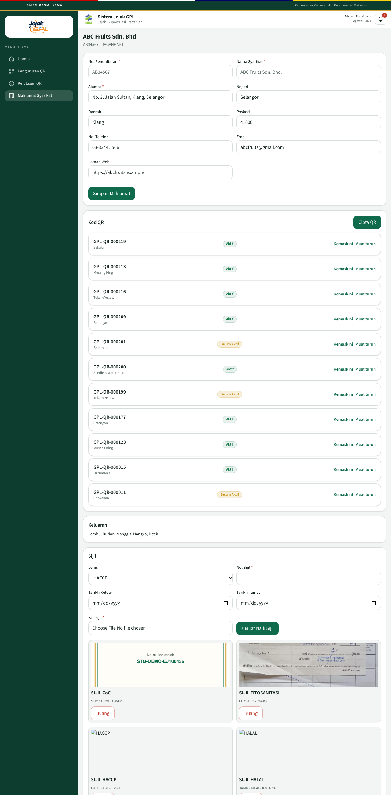
Fail syarikat
For a DagangNet company, No. Pendaftaran and Nama Syarikat stay read-only. Address, phone, email, and website can be updated with Simpan Maklumat.
The Kod QR list on this page has Kemaskini for the public fields of an approved QR, and Muat turun for the image. Cipta QR starts a new QR for this company.
Certificates can be uploaded or removed here, with the same types as the usahawan screen.

Daftar Vendor
Daftar Vendor creates a company record that FAMA manages. It does not create an usahawan login.
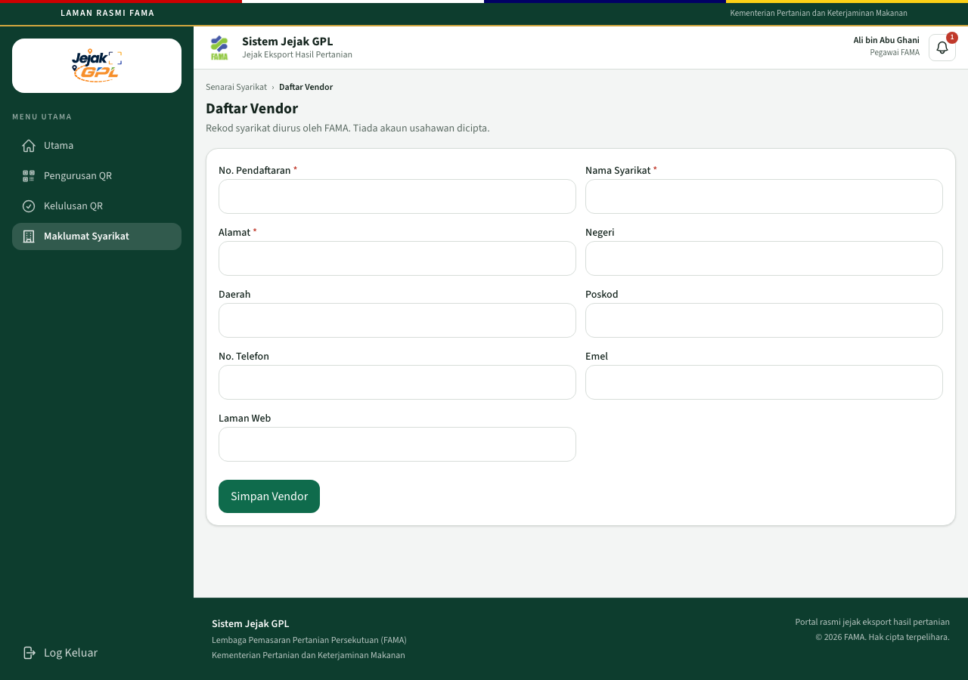
Daftar vendor
Fill the registration number, name, and address. State, district, postcode, phone, email, and website are optional. Click Simpan Vendor.
On a vendor that FAMA created, the registration number and name can be edited later. On a DagangNet company, those two fields stay locked.

Cipta QR
From the company file, click Cipta QR. This path activates the QR immediately. It is the operations shortcut, for example when FAMA captures a vendor at an event. The ordinary path is still the usahawan’s application, then FAMA approval.
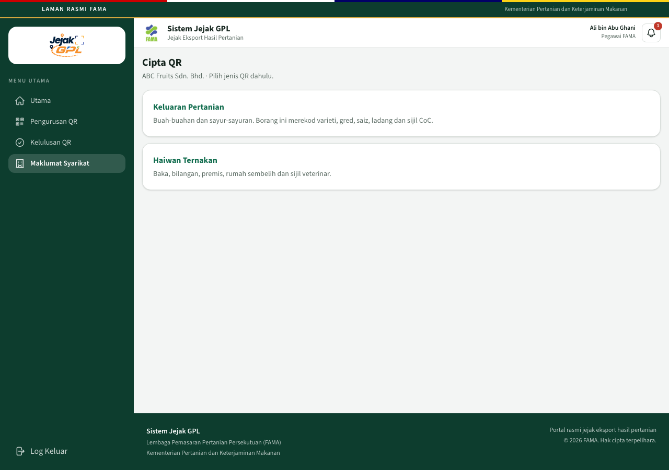
Pilih jenis QR
Choose Keluaran Pertanian or Haiwan Ternakan. The form is the same export form the usahawan uses. The button is Cipta dan Aktifkan QR.
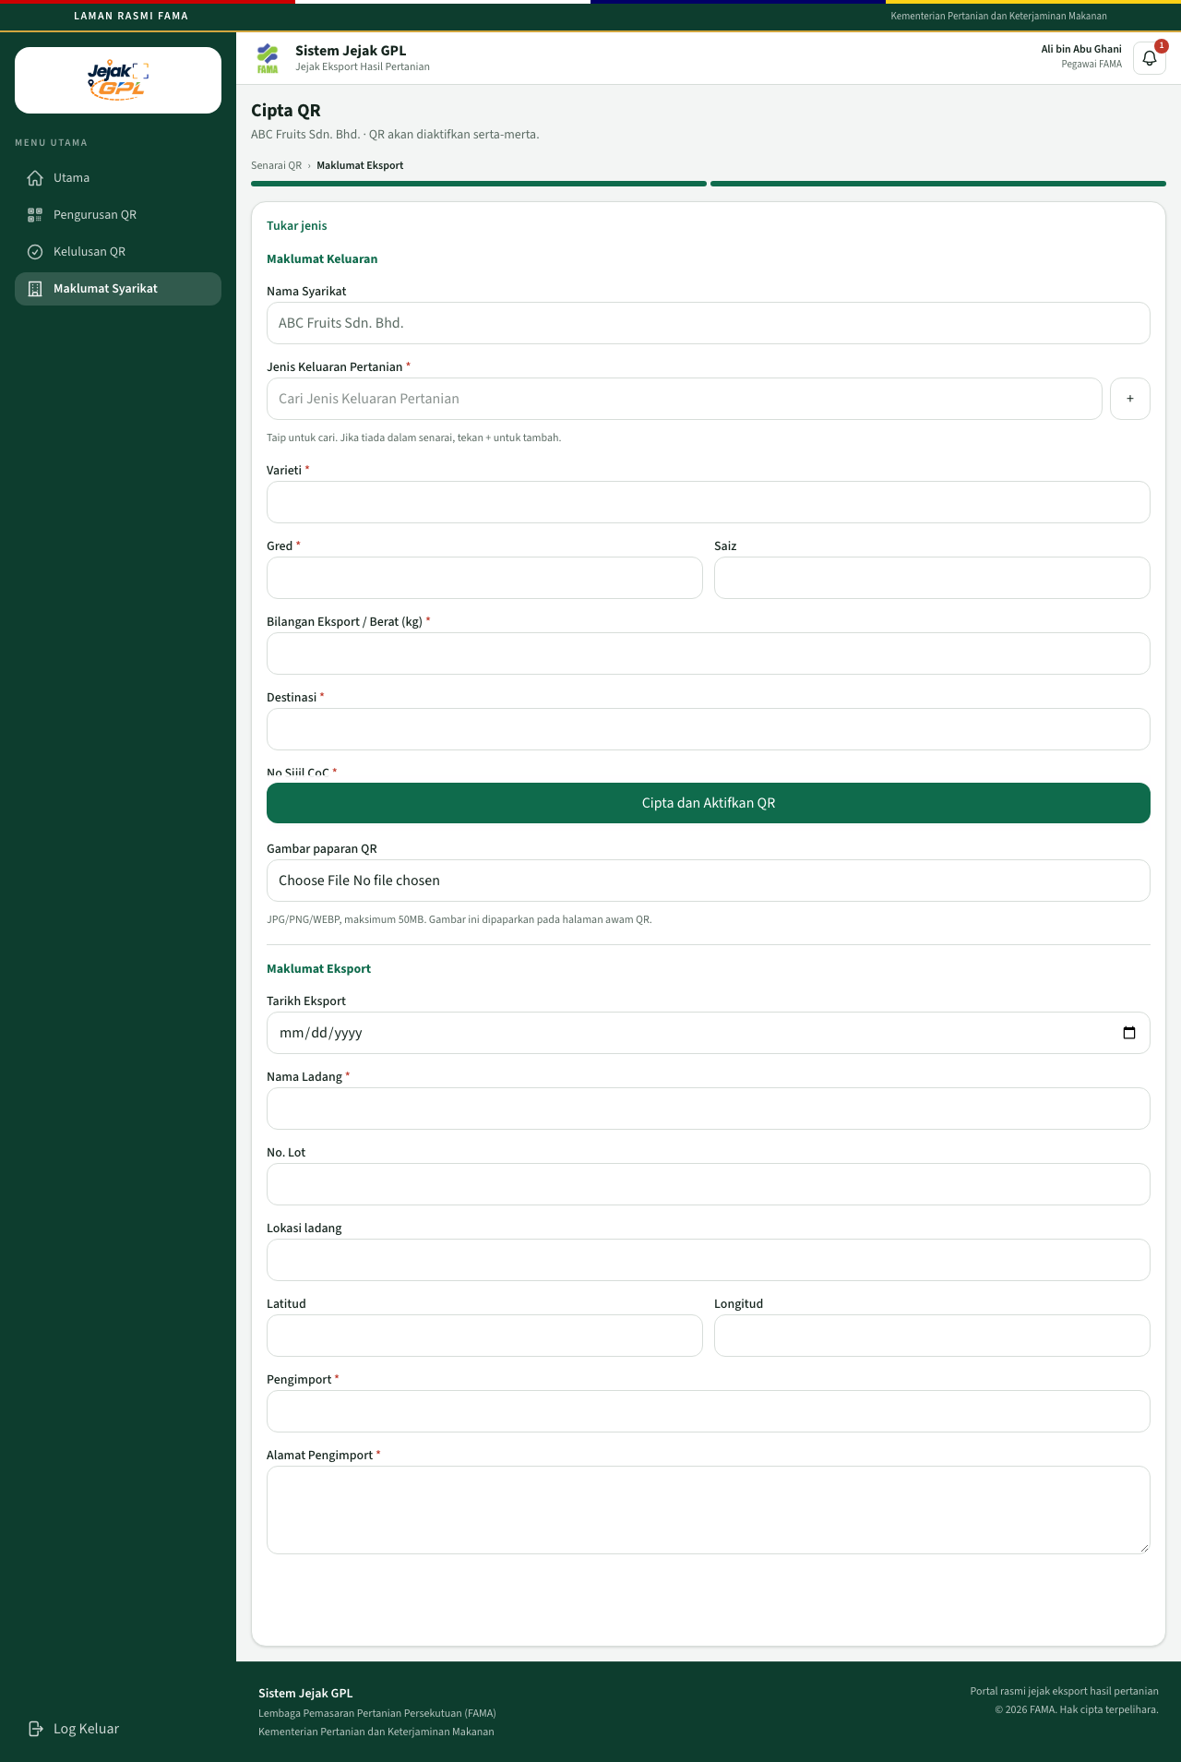
Borang cipta QR
The new public page is already Aktif, because this path approves in one action.

FAMA audit trail
The officer audit trail is not in the left menu. Open:
https://jejakgpl.metadatasystem.my/fama/audit
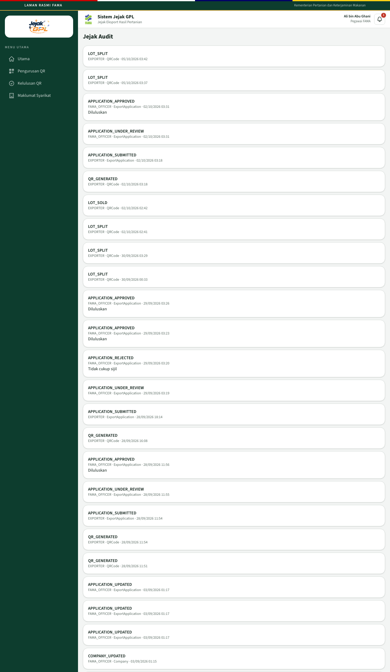
Jejak audit FAMA
It uses the same action names as the usahawan audit, across all companies.

13. Public traceability page
Anyone with the link can open it. No sign-in. The address is:
https://jejakgpl.metadatasystem.my/trace/GPL-QR-000015
Replace the code with the QR you want. Private account data is not on this page.

QR not yet approved
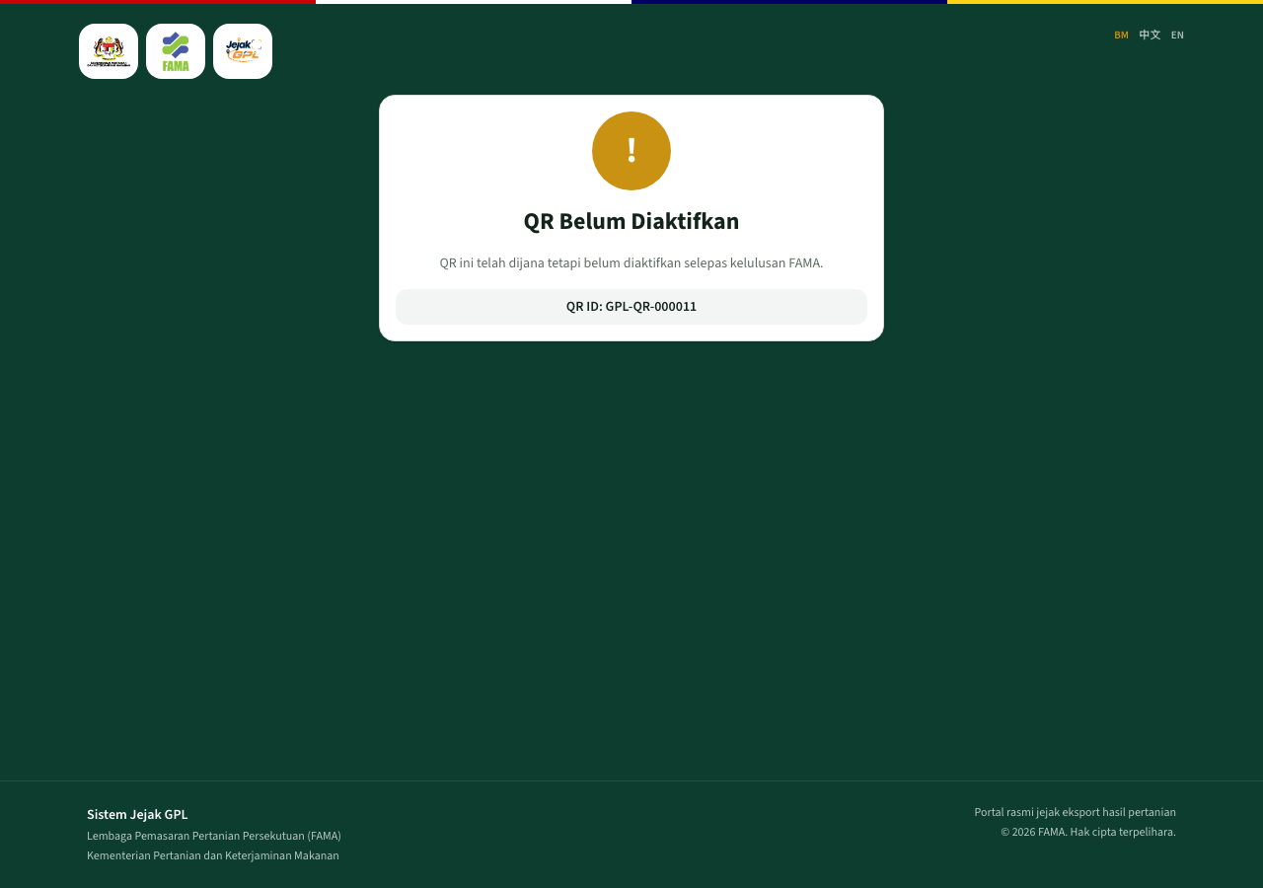
QR Belum Diaktifkan
The title is QR Belum Diaktifkan. The text says the QR has been generated and is not yet active after FAMA approval. Only the QR ID is shown. Product, farm, and importer stay hidden. A rejected application looks the same to the public.

Unknown code
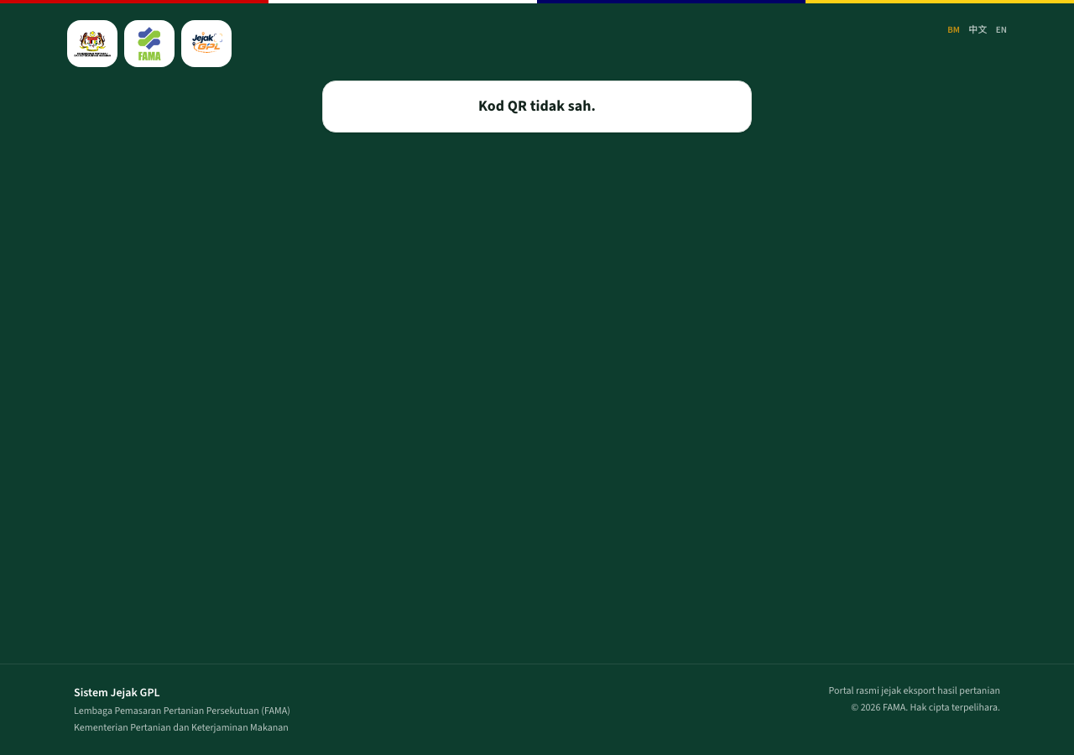
Kod QR tidak sah
A code that does not exist shows Kod QR tidak sah.

Active product page
On a wide screen the page is the desktop profile.
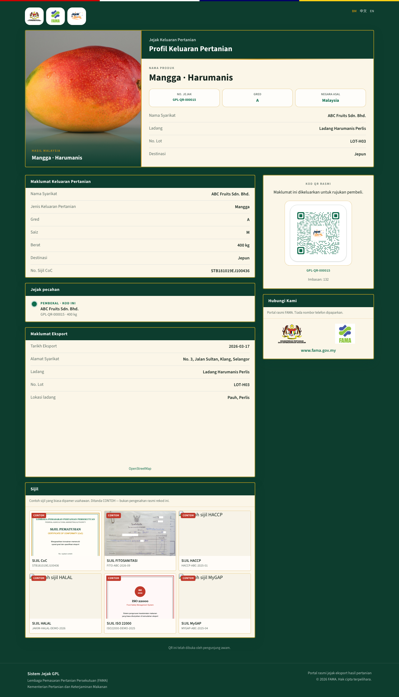
Profil keluaran, aktif
You will see:
- Product and variety, grade, and origin
- Company, farm, lot, and destination
- The official QR and the scan count
- Maklumat Keluaran Pertanian and Maklumat Eksport
- Jejak pecahan — the chain of holders. Kod ini is the code you opened
- A map when the farm has coordinates
- Certificates the company uploaded, with a note that they are copies the entrepreneur displayed, not a fresh check with an authority
- Nutrition, when that produce has it
- The agency strip and contact line
BM, 中文, and EN at the top right switch the language of the same record.
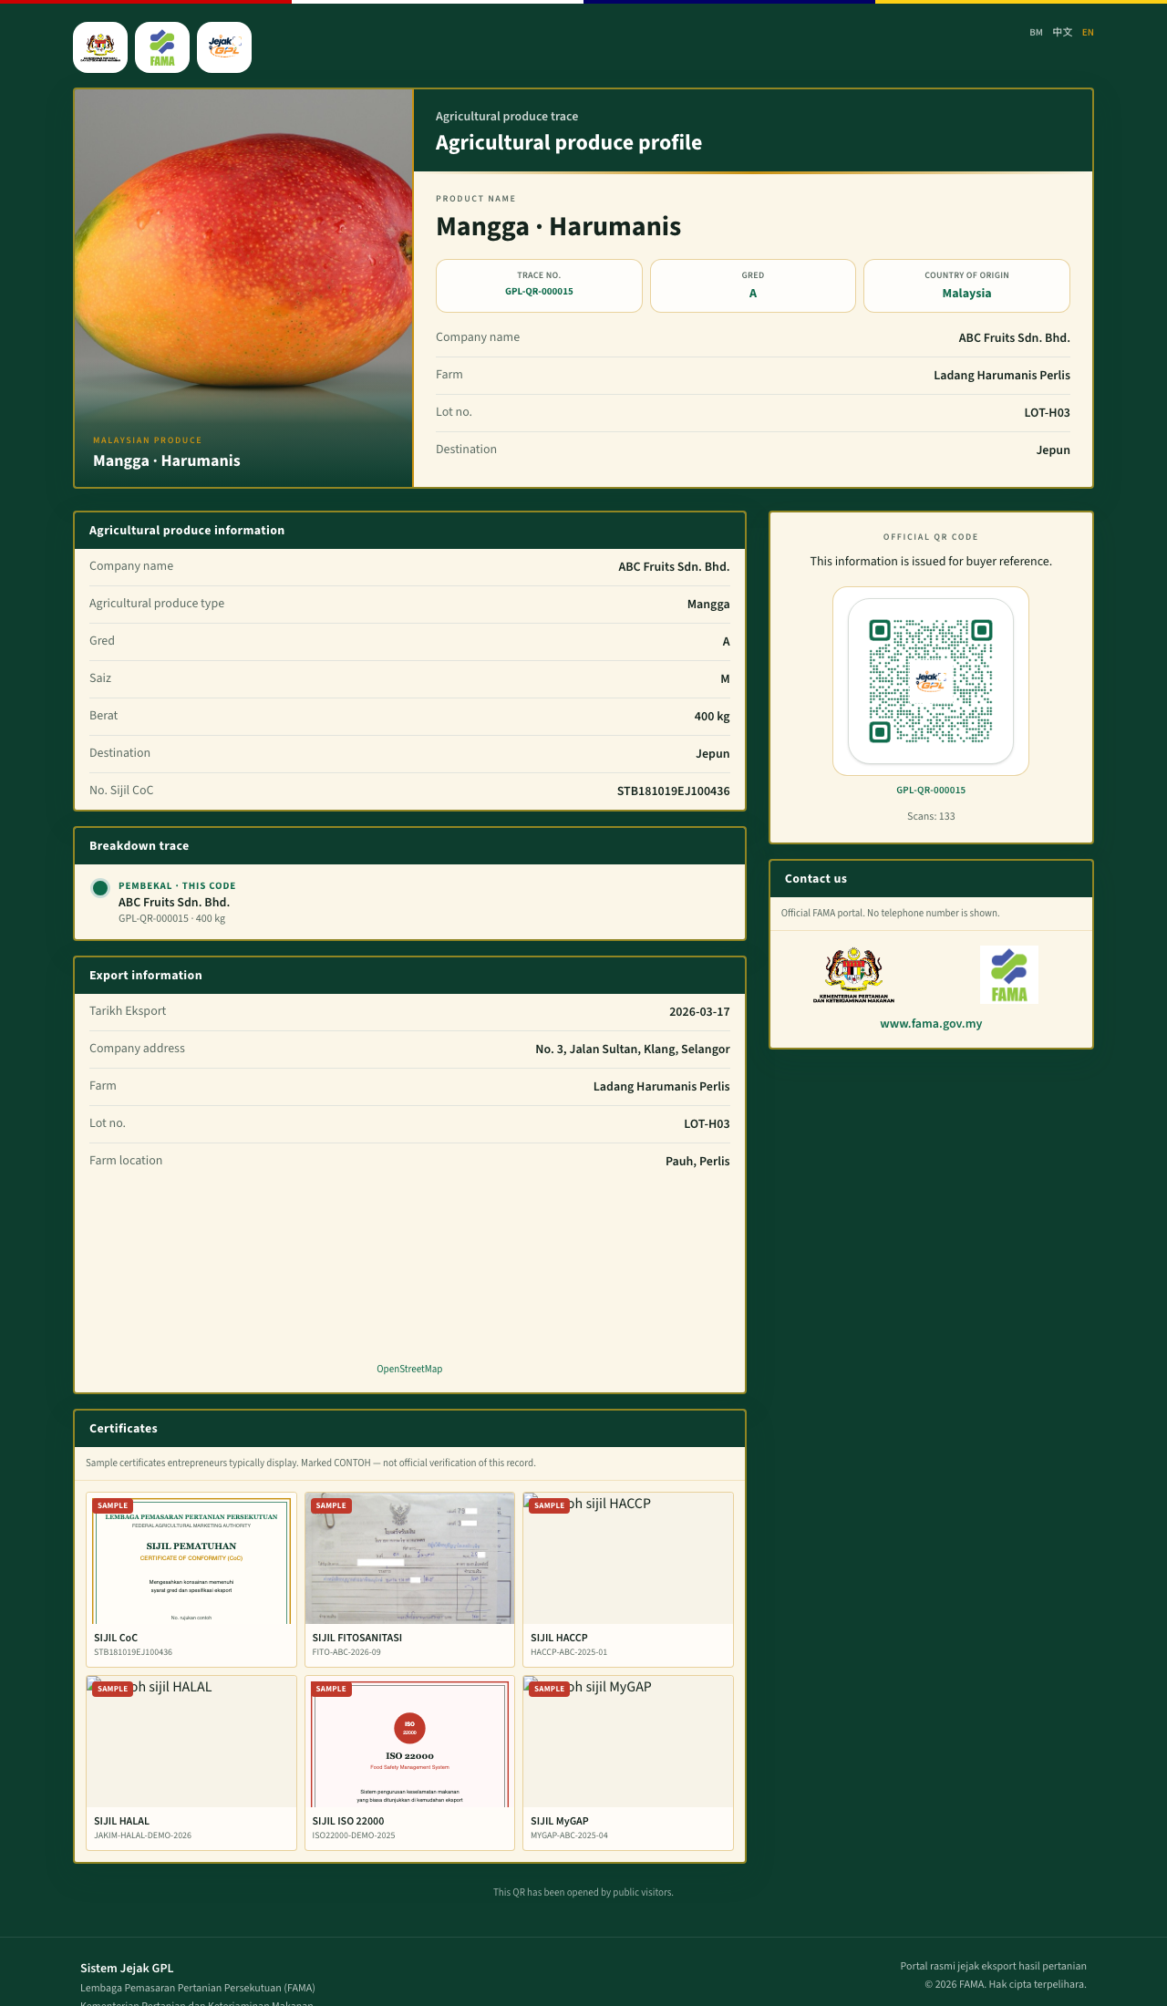
Public page in English
When the lot has been split, Jejak pecahan shows each stop, the role, the quantity, and which code you are holding.
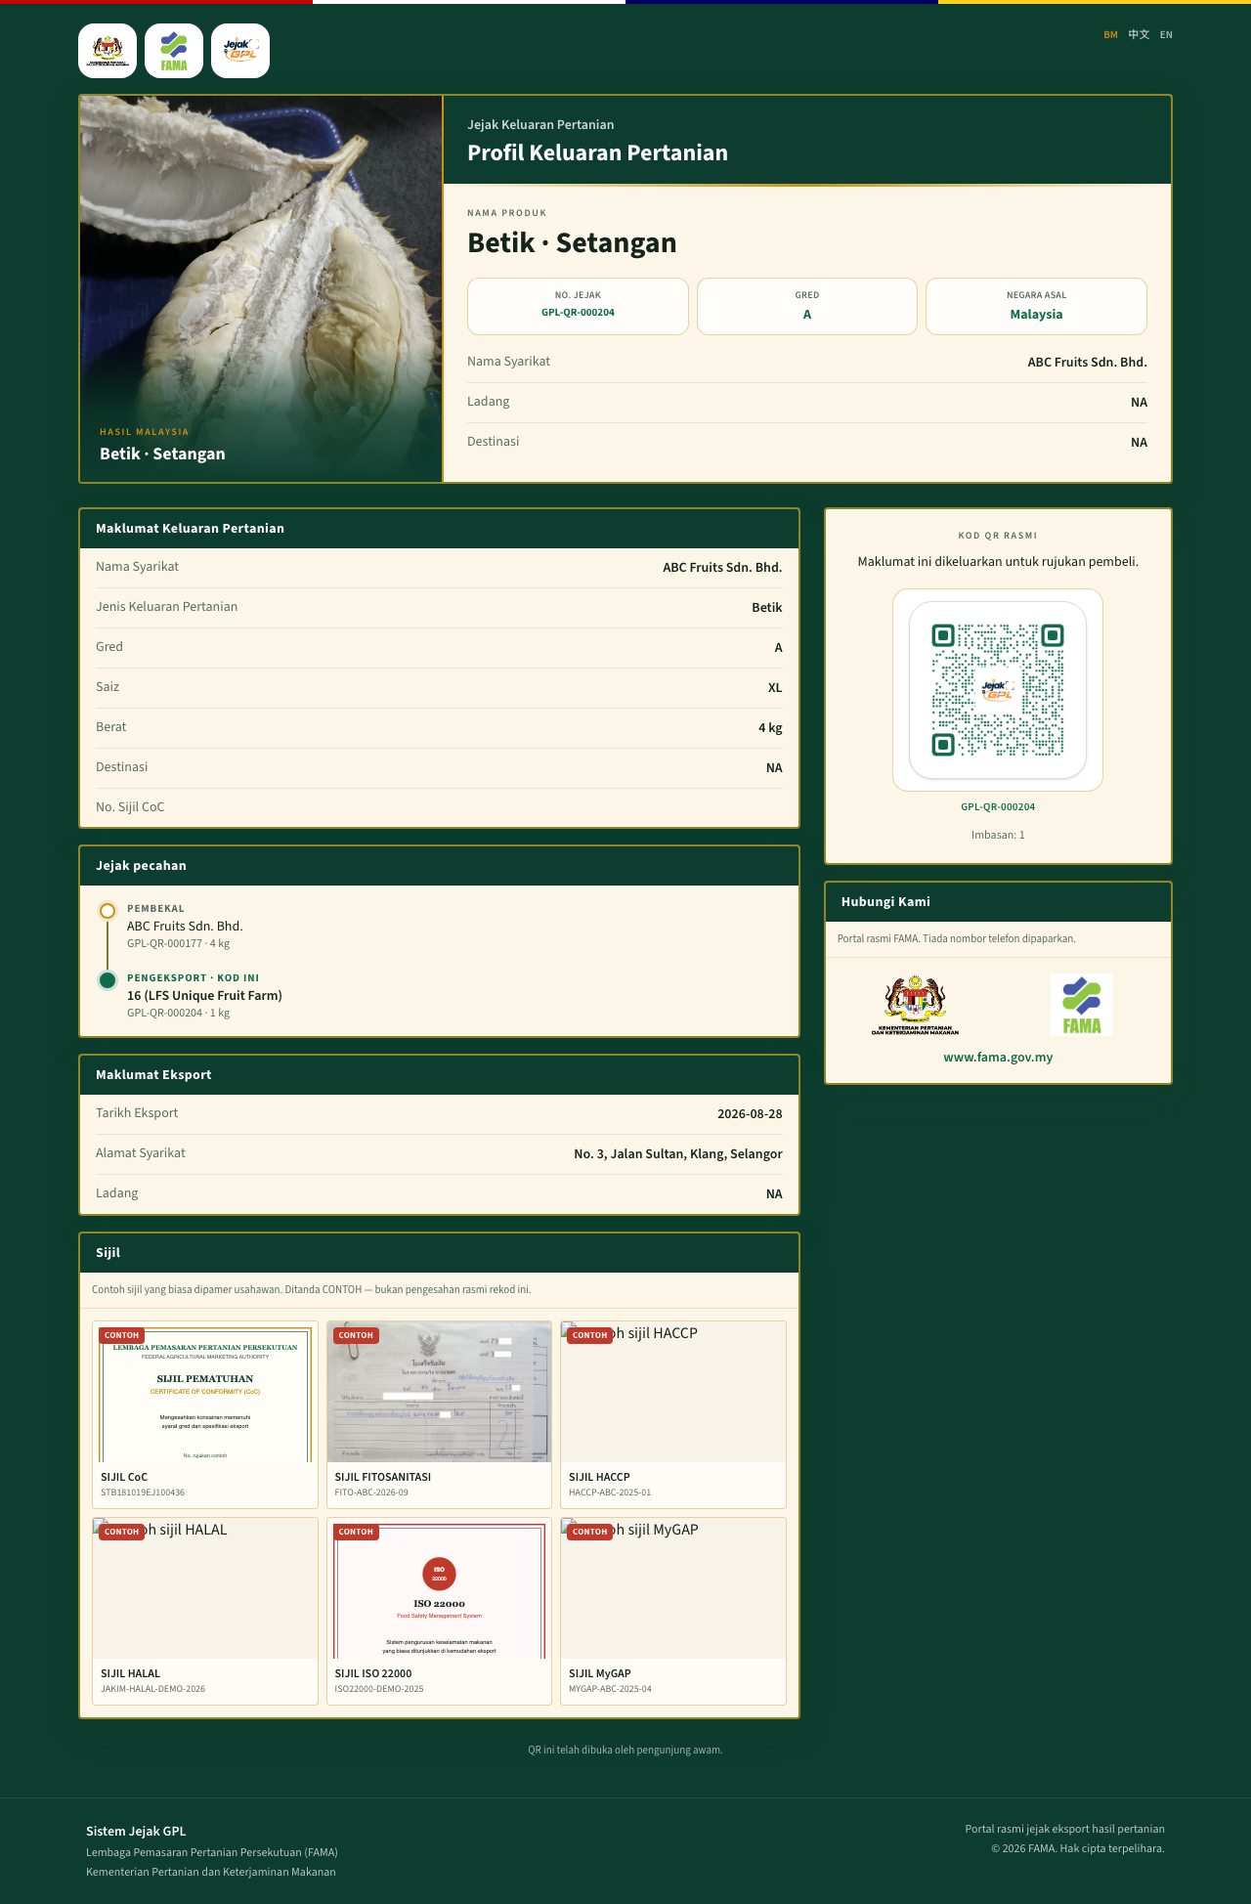
Jejak pecahan with two stops

Waiting for the next company
If a split has been saved and the receiving company has not opened the link while signed in, the public page says QR Menunggu Penerimaan. The product is hidden until that company accepts.

14. Phone layout
On a phone, the usahawan menu moves to the bottom of the screen: Utama, Permohonan, Kod QR, Pecahan, Sijil, Profil.
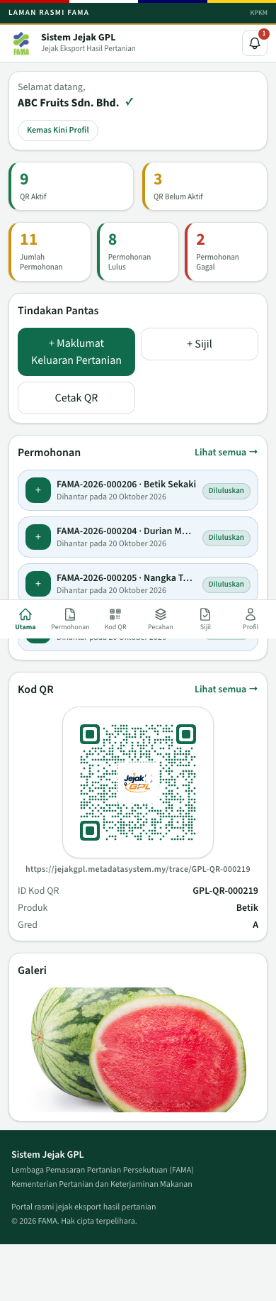
Usahawan home on a phone
The public product page switches to a single column, the pamphlet layout.
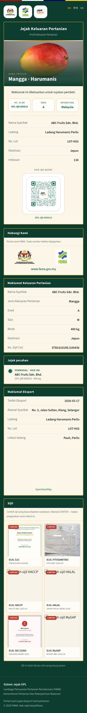
Public page on a phone
Pegawai FAMA on a phone uses the menu button in the header. That opens Menu Utama with Utama, Pengurusan QR, Kelulusan QR, Maklumat Syarikat, and Log Keluar. On a computer those links are the left menu, and the menu page tells you to use that side menu.

15. Statuses
Application status and QR status are separate.

Application
Status on screen | Meaning
Draf | The usahawan can still edit it. FAMA is not deciding yet
Dihantar | Sent to FAMA. The form is locked. The QR is still inactive
Dalam Semakan | An officer has opened it. Sahkan and Tolak are available
Diluluskan | Approved. The QR is Aktif
Ditolak | Rejected. The QR stays Belum Aktif. The reason is on the decision

The path is Draf, then Dihantar, then Dalam Semakan, then either Diluluskan or Ditolak.

QR
Status on screen | Meaning
Belum Dijana | No QR yet
Belum Aktif | The QR ID and the public link exist. The public page does not show the product
Aktif | FAMA has approved, or a FAMA officer created the QR directly, or a consumer pack was sold. The product page is public

A lot also shows Dipegang while the company holds a balance, and Dijual when that piece has been sold on.

16. Demonstration accounts
These accounts are on the live demonstration site. The role switch must match the account.
Who | Role | Email | Password
Ali bin Abu, ABC Fruits Sdn. Bhd. | USAHAWAN | ali@abcfruits.example | Exporter123!
Siti Aminah, MTS Fruits | USAHAWAN | siti@mtsfruits.example | Exporter123!
Ali bin Abu Ghani, Pegawai FAMA | FAMA | aliabu@fama.gov.my | Fama123!

The site already holds many real demonstration records, including approved QR codes such as GPL-QR-000015 (Mangga Harumanis, active) and GPL-QR-000011 (Mangga Chokanan, rejected and inactive). Creating an application, approving one, splitting a lot, or finishing Daftar for a company that already has a login writes into this shared site.
Useful public links:
Link | What you see
/trace/GPL-QR-000015 | Active mango page
/trace/GPL-QR-000011 | QR Belum Diaktifkan
/trace/GPL-QR-999999 | Kod QR tidak sah

17. What this version does not do
- It does not call the live DagangNet or iFAMA systems. Company and staff search uses the built-in lists.
- It does not check a certificate with an issuing authority.
- It does not email a new password. Lupa kata laluan says so.
- It does not print to a hardware label printer. Download gives a PNG or PDF.
- It does not let a rejected application be edited and submitted again.
- It does not expire, suspend, or revoke a QR after activation.
- It does not show private account details on the public page.

18. Messages you may see
Message | What to do
Emel atau kata laluan tidak sah. | Check the email and password
Peranan yang dipilih tidak sepadan dengan akaun ini. | Ali is USAHAWAN. The FAMA officer is FAMA
Tiada rekod dijumpai | The account number or identity card is not in the prototype list
Catatan penolakan diperlukan. | Type a reason, then click Tolak again
Permohonan ini bukan draf dan tidak boleh dikemaskini. | The application has been sent. File a new one if the details must change
Jumlah pecahan melebihi baki kuantiti | The pieces add up to more than the remaining quantity. Lower the quantity and save again
Hanya pemegang lot semasa boleh memecahkan atau menjual lot ini | Sign in as the company that currently holds that row
Lot belum aktif | That QR is not approved yet. Split it after Sahkan
QR Belum Diaktifkan | The public link is real, and FAMA has not approved it, or the application was rejected
QR Menunggu Penerimaan | Sign in as the receiving company and open the link again
Kod QR tidak sah. | The code is not in the system
Sila semak kata laluan. | On FAMA registration, the password and confirmation must match and be at least 8 characters
Sila semak kata laluan dan maklumat pengguna. | On usahawan registration, check the password and that a company was added

